## CHAPTER 1

# **INTRODUCTION**

**1.1 Prelude**

In an era of rapidly evolving technology and increasing environmental concerns, the agricultural sector is witnessing a paradigm shift toward smarter, more sustainable practices. Traditional irrigation methods, often dependent on manual monitoring and guesswork, lead to inefficient use of vital resources such as water and fertilizers. With the growing need to maximize yield while minimizing resource consumption, the integration of smart technology in agriculture has become essential.

The Smart Polyhouse Irrigation Management System aims to revolutionize conventional polyhouse farming through the deployment of IoT-based automation and intelligent environmental monitoring. By incorporating sensors to measure critical parameters such as soil moisture, temperature, humidity, and essential nutrient levels (NPK), this system ensures that crops receive the precise amount of water and nutrients required for optimal growth. The data from these sensors is processed in real-time using microcontrollers like the ESP8266, which not only facilitates communication with a central server but also triggers responsive actions such as activating or deactivating water pumps.

The system’s user-friendly web interface allows farmers to remotely track live sensor data, receive irrigation alerts, and control hardware components from any internet-enabled device. This remote capability significantly reduces manual intervention, saving both time and labor, while also enhancing the accuracy of irrigation scheduling. Moreover, the system architecture is scalable and modular, allowing future upgrades like machine learning-based forecasting or multi-crop support.

The purpose of this project is not just to automate irrigation but to empower farmers with actionable insights, reduce human dependency, and promote eco-friendly farming practices. Through this initiative, we strive to contribute to a more efficient, intelligent, and technologically advanced agricultural ecosystem where precision and sustainability go hand in hand, and innovation leads the way to food security and environmental balance.

**1.2 Importance of Smart Poly-House Irrigation Management System**

The Smart Polyhouse Irrigation Management System offers a solution to the challenges faced by agriculture, especially in the context of sustainable farming. With the depletion of natural resources and unpredictable weather, technology-driven approaches are needed to optimize resource use and ensure sustainable crop production.

* Efficient Resource Utilization: Water scarcity is a significant challenge in agriculture. Our system automates irrigation based on real-time sensor data, ensuring water is used efficiently and reducing waste, thus supporting environmental sustainability.
* Precision and Accuracy in Irrigation: Traditional methods often rely on estimates, leading to over or under-irrigation, both of which harm plants and waste water. Our system provides precise control, delivering water only when necessary, ensuring optimal growth conditions.
* Enhanced Crop Health and Productivity: By monitoring temperature, humidity, and nutrient levels, the system ensures plants receive the right water and nutrients, leading to healthier crops, increased yield, and reduced nutrient deficiencies.
* Cost Savings and Reduced Labor: Manual irrigation requires significant time and effort. Our system enables remote monitoring, reducing labor costs and providing an efficient solution for large-scale farms.
* Data-Driven Decision Making: The system collects real-time data, allowing for better decision-making, predictive analysis, and optimized irrigation schedules, leading to improved long-term crop management.
* Sustainability and Environmental Benefits: By integrating IoT, the system reduces overuse of resources like water and fertilizers, minimizing the carbon footprint and promoting eco-friendly farming practices.

## 1.3 Block Diagram

## The block diagram shown in Fig 1.1 illustrates a smart agriculture monitoring and irrigation system that utilizes Internet of Things (IoT) technology to automate the irrigation process based on real-time environmental data. The system integrates multiple sensors including a soil moisture sensor, a temperature sensor, and an NPK sensor. These sensors collect critical data such as the moisture content of the soil, ambient temperature, and the levels of essential nutrients—Nitrogen (N), Phosphorus (P), and Potassium (K)—present in the soil. All the collected data is transmitted to an ESP8266 board, a Wi-Fi-enabled microcontroller that processes the inputs and sends them to a cloud platform.

## 

## Fig 1.1: Block Diagram of Smart Poly-House Irrigation Management System

## Once the data reaches the cloud, it is stored and compared against pre-set threshold values to determine whether the soil conditions are suitable or if irrigation is required. Based on this analysis, the system decides whether to turn the water pump on or off. Simultaneously, the data is made accessible through a web-based interface. This website allows users, such as farmers, to log in or register to monitor sensor readings in real-time, control the irrigation system remotely, and receive feedback or alerts. The user can also manually turn the system on or off depending on specific needs.

## 

## The final output of the system is the operation of a water pump, which is automatically controlled to irrigate the crops when the soil moisture level is below the desired threshold.

## This intelligent system not only ensures efficient use of water but also supports better crop management by providing insights into soil nutrient levels and environmental conditions. Overall, this smart irrigation system is a practical solution to enhance agricultural productivity, reduce water wastage, and minimize the need for constant human supervision.

**1.4 Motivation**

The primary motivation behind this project is to address the challenges faced by farmers due to inefficient water management and the lack of real-time monitoring of soil and environmental conditions. In many agricultural regions, especially those dependent on traditional farming practices, irrigation is carried out manually without precise knowledge of the actual needs of the crops. This often leads to over-irrigation or under-irrigation, which not only wastes valuable water resources but also negatively affects crop health and yield. Additionally, farmers often lack immediate access to critical information like soil nutrient levels and weather conditions, making it difficult to make informed decisions. By leveraging IoT technology, this project aims to provide a smart, automated solution that monitors soil moisture, temperature, and nutrient levels in real time, and accordingly controls irrigation through a user-friendly web interface. This system not only helps conserve water but also empowers farmers to adopt modern, data-driven farming practices, ultimately leading to improved agricultural productivity, reduced labour, and sustainable resource usage.

**1.5 Objective of the Project**

The main objective of this project is to develop a smart, automated agricultural system that ensures an ideal nutritional and environmental setting for optimal plant growth, particularly within a hydroponic or controlled greenhouse setup. By integrating advanced sensor technologies, the system continuously monitors key parameters such as moisture, temperature, and nutrient levels, allowing it to make real-time decisions that reduce human intervention and conserve water. The use of a greenhouse structure provides natural lighting, while supplemental lighting ensures plant growth throughout all seasons. A virtual environment is also created to simulate and analyse different growing conditions, enhancing planning and efficiency.

* To create an intelligent, automated system that ensures optimal nutritional and environmental conditions for plant growth using sensor data analysis.
* To enhance plant productivity by integrating climate control, greenhouse conditions, and supplemental lighting for year-round cultivation.
* To develop a user-friendly graphical interface and virtual environment for real-time monitoring, control, and simulation of agricultural conditions.
* To promote water conservation and reduce manual labor by automating hydroponic system maintenance and continuous sensor-based decision-making.

**1.6 Issues of the Project**

Traditional farming faces key issues that reduce efficiency and crop yield. Inefficient water usage due to manual irrigation often leads to wastage, while the lack of real-time monitoring makes it hard for farmers to make informed decisions. Manual labour dependency increases effort and time. Seasonal limitations, inconsistent nutrient delivery in hydroponics, and the absence of user-friendly technology further hinder productivity. Additionally, unpredictable environmental changes can negatively impact plant health. These challenges highlight the need for an automated, smart agricultural system.

**1.7 Tools Used**

**1.7.1 Hardware Tools**

* SESP8266 (NodeMCU)
* Arduino UNO
* Soil Moisture Sensor
* Temperature Sensor (e.g., DHT11)
* NPK Sensor
* Water Pump
* Relay Module
* Wires, Breadboard, and Connectors

**1.7.2 Software Tools**

* Arduino IDE
* Visual Studio Code
* Node.js
* GitHub

**1.8 Applications**

* Hydroponic Farming – Precise control of nutrient levels and environmental conditions for soil-less agriculture.
* Greenhouse Automation – Monitoring and adjusting temperature, humidity, and lighting to optimize plant growth.
* Urban and Rooftop Farming – Ideal for space-limited environments, enabling efficient, high-yield cultivation.
* Remote Agricultural Monitoring – Enables farmers to track and control conditions from remote locations.
* Precision Agriculture – Data-driven farming practices for maximizing productivity and minimizing resource use.
* Commercial Crop Production – Enhances output quality and consistency for large-scale food producers.
* Nurseries and Plant Propagation Units – Maintains optimal conditions for seedling growth and propagation.

**1.9 Organization of Report**

The report is organised as shown below:

* **Chapter 1:** Introduces the concept and importance of smart polyhouse irrigation using IoT.
* **Chapter 2:** Summarizes past research and technological developments in smart irrigation and polyhouse farming.
* **Chapter 3:** Explains the architecture and workflow of the proposed smart polyhouse system.
* **Chapter 4:** Lists and describes the hardware (ESP8266, Arduino UNO, sensors, relay, pump) and software (Arduino IDE, Node.js, VS Code etc.) used.
* **Chapter 5:** Covers the backend (Node.js APIs, database handling), frontend (dashboard design, login/authentication), and how real-time sensor data is visualized and used for decision-making in the application.
* **Chapter 6:** Describes the setup of physical components including sensors, wiring, relay-motor control via Arduino, and integration with ESP8266 for data collection and execution.
* **Chapter 7:** Presents step-by-step execution, from code uploading to sensor reading, real-time dashboard display, and remote motor control
* **Chapter 8:** Summarizes the project achievements automation, resource conservation, and productivity enhancement. Future scope includes AI-based predictions, mobile app integration, and expanding to multi-crop support.

**CHAPTER 2**

# **LITERATURE SURVEY**

**2.1 Introduction**

This chapter provides a brief review of existing research and technologies in the area of smart irrigation and polyhouse automation. It focuses on systems that use IoT devices, sensors, and microcontrollers to monitor environmental factors like soil moisture, temperature, humidity, and nutrient levels. The survey helps in identifying effective methods and tools that can be applied in designing an efficient, automated irrigation system for polyhouse farming, forming the foundation for the development of our project.

**2.2 Literature Review**

Deshpande et al. [1] in their paper have proposed that a soil moisture sensor, temperature, and humidity sensors are placed in the root zone of the plant to transmit data to an Android application. The threshold value of the soil moisture sensor is programmed into a microcontroller to regulate the water quantity. Temperature, humidity, and soil moisture values are displayed on the Android application. This paper provides advanced knowledge of efficient plant irrigation management using wireless sensor networks and Internet of Things technology. It has also demonstrated that a sensor-based monitoring system can measure soil moisture, temperature, and humidity and transfer this information to an Android application. Using this technology, water distribution can be effectively managed, and real-time data on environmental conditions can be monitored. Finally, the experiments have shown that automated irrigation using a microcontroller-based system is more efficient than traditional methods.

In this paper Naik et al. [2] proposed that the analysis is conducted automatically without the need for manpower, where a buzzer is activated to enhance energy efficiency. This paper provides advanced knowledge of automated monitoring systems using sensor-based technology. It has also demonstrated that an automated system can detect conditions and trigger a buzzer without human intervention, contributing to improved energy savings.

Using this technology, energy consumption can be effectively managed, ensuring optimal utilization. Finally, the experiments have shown that automation in energy-saving systems is more efficient compared to manual operations.

The paper which was proposed by Choudhari and Harde [3] stated that this system enhances the lifespan of the system by reducing power consumption, leading to overall lower energy usage. This paper provides advanced knowledge of energy-efficient irrigation management using automated control systems. It has also demonstrated that by optimizing power consumption, this technology can be effectively utilized in cricket stadiums, golf stadiums, and public garden areas for proper irrigation. Using this system, irrigation can be managed efficiently while ensuring minimal energy wastage. Finally, the experiments have shown that implementing this technology significantly improves system longevity and reduces overall power consumption compared to conventional methods.

In [4] Agrawal et al. have proposed that a smart drip irrigation system is an innovative and efficient solution designed to automate and regulate watering processes without requiring manual intervention. This system ensures optimal water usage by automatically controlling the irrigation process, reducing human effort, and minimizing water wastage. This paper provides advanced knowledge of automated irrigation management using smart control systems integrated with modern communication technologies. It has also demonstrated that the system can be remotely controlled through email notifications, allowing for a dual-mode operation. The system can function autonomously by receiving automated email alerts or can be manually controlled by sending emails, giving users the flexibility to determine whether irrigation should be activated based on real-time weather conditions. This feature makes the system adaptable to environmental changes, preventing unnecessary water usage during rainy or humid conditions. Using this technology, irrigation can be managed efficiently, ensuring that water is delivered only when needed. The ability to regulate irrigation based on real-time weather data contributes to sustainable agriculture, conserves water resources, and reduces operational costs. Finally, the experiments have shown that implementing this smart drip irrigation system significantly improves efficiency, reliability, and sustainability compared to traditional manual irrigation methods.

Rajpal et al. in [5] have claimed that the combination of hardware and software in this system provides an efficient irrigation controller that is cost-effective and user-friendly. This system integrates both physical components and intelligent software to ensure seamless irrigation management, making it accessible for a wide range of users, including farmers, gardeners, and landscape managers. This paper provides advanced knowledge of smart irrigation systems that leverage automation and digital control to optimize water usage. It has demonstrated that by utilizing a combination of sensors, microcontrollers, and software applications, irrigation can be precisely managed, ensuring that water is distributed based on real-time environmental conditions. The system is designed to be highly user-friendly, allowing even individuals with minimal technical knowledge to operate and control irrigation settings effortlessly. The affordability of this technology further enhances its potential for widespread adoption, making it a viable solution for small-scale farmers as well as large agricultural enterprises. Using this technology, irrigation processes can be automated, reducing manual labour while improving efficiency in water conservation. The integration of smart software enables remote monitoring and control, allowing users to adjust irrigation schedules based on weather conditions, soil moisture levels, and crop requirements. Finally, the experiments have shown that implementing this smart irrigation controller not only reduces water wastage and operational costs but also extends the lifespan of irrigation equipment by optimizing water flow, making it a sustainable and practical solution compared to conventional irrigation methods.

Lorvanleuang S and Zhao [6] have indicated in their paper that the use of the Internet of Things (IoT) in a polyhouse environment to enhance agricultural productivity and efficiency. A polyhouse is a fully covered structure that minimizes the impact of external environmental factors, creating a controlled atmosphere for crop cultivation. Since the structure is enclosed, external elements such as insects are unable to enter, reducing the risk of crop damage and significantly lowering the need for insecticides. This controlled environment not only ensures healthier crops but also contributes to sustainable and eco-friendly farming practices. This paper provides advanced knowledge of smart agriculture through the integration of IoT-based technologies in polyhouse farming. It has demonstrated that by using various sensors connected to the internet, real-time monitoring of critical parameters such as temperature, humidity, and soil moisture can be achieved. The collected data is processed and analysed, enabling farmers to make informed decisions regarding irrigation, ventilation, and fertilization, thereby optimizing crop growth

conditions. Using this technology, farmers can effectively manage crop production while reducing dependency on chemical pesticides. The IoT-enabled system allows for remote monitoring and control, ensuring that environmental conditions remain within optimal ranges for plant growth. Finally, the experiments have shown that implementing IoT in polyhouse farming leads to improved crop yield, reduced use of chemical inputs, and enhanced overall efficiency compared to traditional open-field farming methods.

In [7] Harde and Choudhari have proposed an irrigation system where the drip irrigation mechanism is controlled using a Bluetooth module. This system enables efficient water management by automating the ON/OFF operation of the drip irrigation system through wireless communication, eliminating the need for manual intervention. The integration of Bluetooth technology simplifies irrigation control, making it more convenient and user-friendly for farmers and agricultural workers. This paper provides advanced knowledge of smart irrigation systems utilizing wireless communication technologies for enhanced efficiency. It has demonstrated that by replacing traditional data storage devices with a direct Bluetooth-based control mechanism, the system becomes more cost-effective and requires minimal hardware components. Additionally, the reduction of manpower in irrigation management results in significant labour savings, making the system a practical solution for both small- and large-scale agricultural applications.

Lorvanleuang and Zhao [8] have designed an automated irrigation system that is aimed at optimizing water usage by minimizing wastage. This system ensures that crops receive the necessary amount of water efficiently, reducing excessive irrigation and conserving water resources. By integrating automation, the irrigation process becomes more precise and effective, eliminating the challenges associated with traditional manual watering methods. This paper provides advanced knowledge of smart irrigation management through the use of automated control systems and mobile technology. It has demonstrated that by incorporating an Android application, users can remotely monitor and control the water requirements of their farms. This feature allows farmers to adjust irrigation settings based on real-time conditions, ensuring that crops receive adequate water without unnecessary human intervention. The ability to remotely access and control the irrigation system enhances convenience, making it more accessible for modern agricultural practices. Using this technology, irrigation management becomes more efficient, reducing

dependency on manual labor while ensuring optimal water distribution. The integration of a mobile-based monitoring system allows farmers to make data-driven decisions, improving overall agricultural productivity. Finally, the experiments have shown that implementing this automated irrigation system leads to improved water conservation, increased crop yield, and reduced operational costs compared to traditional irrigation methods.

Seenu et al. [9] in their paper have proposed a system that monitors soil moisture content and temperature in a farming area, allowing for efficient water management. By integrating sensor-based technology, the system ensures that real-time environmental data is collected and analysed to optimize irrigation. This approach helps in conserving water while maintaining ideal conditions for crop growth, making it a valuable tool for modern agriculture. This paper provides advanced knowledge of smart farming techniques by utilizing wireless communication and automated irrigation control. It has demonstrated that farmers can monitor crucial soil parameters remotely and control the watering system using an Android device equipped with Wi-Fi connectivity. This enables real-time adjustments based on the current soil conditions, reducing water wastage and ensuring optimal hydration levels for crops. With the implementation of this technology, farmers gain the ability to remotely access and manage irrigation through their mobile devices. The system significantly enhances irrigation efficiency, reducing manual labour while ensuring precise water distribution. As a result, agricultural productivity improves, operational costs decrease, and water conservation efforts are effectively supported compared to conventional irrigation methods.

As summarized in the work of Dhore et al. [10] that agriculture serves as the foundation for all industries by providing essential raw materials, making efficient water management crucial for sustainable crop cultivation. Different crops require varying water levels at different growth stages, necessitating a system that can monitor and regulate water distribution effectively. By optimizing irrigation processes, water usage can be minimized while ensuring adequate hydration for crops, ultimately improving agricultural productivity. This paper provides advanced knowledge of precision irrigation techniques aimed at maintaining optimal water levels throughout the cultivation cycle. It has demonstrated that by utilizing automated irrigation systems, farmers can monitor and control water supply based on real-time requirements. This approach not only conserves

water but also enhances crop yield by providing the necessary moisture levels at critical growth stages. With the implementation of this technology, irrigation can be managed more efficiently, reducing dependency on manual intervention while ensuring consistent water availability. The system contributes to sustainable farming practices by preventing overwatering and underwatering, ultimately leading to improved resource utilization, cost savings, and increased agricultural efficiency compared to traditional irrigation methods.

A literature review presented by Kachor and Ghodinde [11] have explained that traditional agricultural methods have certain limitations that make them unsuitable for efficient polyhouse monitoring and control. To enhance productivity and crop quality, there is a need for an advanced system that can effectively monitor and regulate environmental parameters. Proper monitoring and control of field conditions create an optimal environment for crop growth, leading to improved yield and quality. This paper provides advanced knowledge of intelligent polyhouse management using automation technologies. It has demonstrated that by incorporating a Programmable Logic Controller (PLC) system, specifically the Delta PLC, the monitoring and control process becomes more efficient, reliable, and cost-effective. The use of PLC-based systems simplifies wiring, reducing overall installation costs and making polyhouse automation more accessible to common farmers. Additionally, the integration of a wireless network solution further enhances the system’s usability by allowing remote access and real-time control. With the implementation of this technology, polyhouse farming becomes more affordable and efficient. By utilizing Proportional-Integral-Derivative (PID) control, the system ensures precise environmental adjustments, leading to a significant increase in production. The combination of PLC automation and intelligent control mechanisms provides a scalable and practical solution that improves agricultural output while reducing labour and operational costs compared to conventional polyhouse management techniques.

A detailed review conducted by Hadi et al. [12] serves as the basis for understanding a system for controlling home appliances using an Android application, enabling seamless automation. The system utilizes an Arduino Mega and a Wi-Fi module to establish communication between the smartphone and home devices. The Wi-Fi module receives user commands from the smartphone, which are then processed by the Arduino to control the respective appliances. An Android application was developed using Android SDK to facilitate user interaction and system control. This paper provides advanced knowledge of

smart home automation through wireless communication technologies. It has demonstrated that by leveraging Wi-Fi connectivity, users can efficiently monitor and manage household appliances remotely. Wireless technologies such as RFID, Zigbee, Bluetooth, GSM, and Wi-Fi offer various advantages depending on their specifications and applications. However, Wi-Fi-based automation stands out due to its reliability, ease of implementation, and broad accessibility. By utilizing Wi-Fi, the proposed system ensures a more advanced and flexible home automation solution, enhancing convenience, energy efficiency, and overall user experience compared to traditional wired control methods.

Rokade et al. [13] they proposed a key technological advancement in digital agriculture that are set to have a significant impact on the industry. The integration of artificial intelligence (AI) techniques and big data analytics addresses major agricultural challenges related to productivity and sustainability. These emerging innovations are transforming agriculture from traditional farming methods into a highly automated and data-driven industry, enhancing efficiency and precision in agricultural practices. This paper provides advanced knowledge of digital agriculture, highlighting the role of remote sensing, AI, and robotic systems in modernizing farming operations. It has demonstrated that these technologies enable farmers to achieve accurate and transparent monitoring of crops and livestock, improving yield and quality while minimizing environmental impact. The application of digital tools ensures better decision-making at both regional and national levels, leading to more efficient resource management. With the implementation of these technologies, agriculture is evolving into a smarter and more sustainable industry. However, certain challenges, including accuracy limitations, interoperability issues, data storage constraints, computational power requirements, and the reluctance of farmers to adopt new technologies, must be addressed. Overcoming these obstacles will be crucial for the widespread adoption of digital agriculture, ensuring its successful transformation into an advanced and efficient sector.

Kumaret al. [14] in their paper they have proposed an advanced automated irrigation system utilizing a microcontroller (NodeMCU) integrated with a Wi-Fi module (ESP8266). The IoT-based smart irrigation system enhances agricultural efficiency by automating water management based on real-time environmental data. The system includes a soil moisture sensor, DHT11 temperature and humidity sensor, raindrop sensor, DC motor, and NodeMCU microcontroller. The soil moisture sensor measures the water

content in the soil, and the NodeMCU processes this data to determine if irrigation is required. When moisture falls below a set threshold, the DC motor activates a water pump to irrigate crops. Irrigation stops once the required moisture level is achieved, preventing water wastage. The DHT11 sensor monitors atmospheric conditions, helping maintain optimal temperature and humidity levels essential for crop growth. Meanwhile, the raindrop sensor detects rainfall and pauses irrigation during wet conditions. If soil moisture remains low after rainfall, the system reactivates irrigation, ensuring consistent soil hydration. All data is transmitted to the Blynk cloud via Wi-Fi, allowing farmers to monitor and control the system remotely. This remote access offers convenience and supports better decision-making. Overall, the system promotes sustainable farming by reducing manual labor, conserving water, and improving crop yield through automation and precise environmental control.

Bharathi et al. [15] have successfully implemented a smart water irrigation system designed to optimize water usage through intelligent automation. The system is equipped with self-regulating capabilities, ensuring efficient water distribution based on real-time soil moisture conditions. The study demonstrates that the irrigation process operates only when necessary, preventing unnecessary watering when soil moisture levels are already sufficient or when rainfall occurs. This approach helps in conserving water while maintaining ideal hydration for plant growth. This paper provides advanced knowledge of smart irrigation technology, emphasizing automated control systems that enhance water conservation and prevent over-irrigation. It has demonstrated that the proposed network effectively monitors and regulates soil moisture, ensuring that crops receive water only when required. By avoiding excessive watering, the system prevents plant damage and reduces the risk of contamination, making irrigation more sustainable and efficient. With the implementation of this technology, agricultural water management can be further improved by incorporating additional sensors such as pH sensors, light detection modules, soil condition checkers, and crop observation tools. Integrating image processing techniques could enhance system accuracy, enabling more precise crop monitoring and decision-making. Moving forward, the study suggests that increased research in agriculture-related technologies is essential for advancing sustainable farming practices and improving overall agricultural productivity.

Lund et al. [16] they explained a commercialized sensing system, which integrates soil electrical conductivity and pH mapping for enhanced agricultural monitoring. This system enables precise soil analysis by increasing measurement density through direct pH measurement. By incorporating advanced sensing technology, farmers can obtain accurate and high-resolution soil data, allowing for better-informed decisions regarding soil health and crop management. This paper provides advanced knowledge of soil sensing technologies, emphasizing the importance of pH and electrical conductivity in plant growth and nutrient absorption. It has demonstrated that accurate measurement of these parameters helps optimize soil conditions, ensuring that crops receive the necessary nutrients for healthy development. By leveraging direct pH measurement, the system enhances soil analysis capabilities, making it a valuable tool for precision agriculture. With the implementation of this technology, soil monitoring becomes more efficient, enabling farmers to improve crop yield and soil fertility management. The integration of high-density soil measurement techniques ensures better nutrient distribution and resource allocation. Moving forward, advancements in soil sensing technology could further enhance precision farming, leading to improved sustainability and productivity in agriculture.

In [17] Umate has made an autonomous robotic system for efficient nutrient management in agriculture. This system is equipped with advanced capabilities to test soil for nutrient deficiencies, assess water requirements, and optimize fertilizer application. By performing real-time soil tests, the robot ensures that crops receive the necessary nutrients and water for healthy growth, reducing manual labour and enhancing precision in farming practices. This paper provides advanced knowledge of automated nutrient and irrigation management, emphasizing the role of robotics in modern agriculture. It has demonstrated that the system not only analyses soil conditions but also administers fertilizers and water based on the nutrient test results. Additionally, the system is capable of alerting farmers when fertilizer application is required, ensuring timely intervention to support crop growth and yield optimization. agricultural efficiency is significantly improved by reducing wastage of resources and enhancing crop health. The integration of autonomous robots in farming enables precise nutrient management, reducing dependency on manual intervention while promoting sustainable farming practices. Future advancements in robotic agriculture could further refine this system, integrating AI and data analytics to enhance decision-making and overall farm productivity.

The paper proposed by Londhe and Galande [18] have proposed an advanced drip irrigation system which is fully monitored and controlled using an ARM9 processor. The system incorporates a soil moisture sensor to continuously monitor the moisture content of the soil, ensuring optimal irrigation. Based on the sensor readings, a solenoid valve is automatically activated or deactivated, allowing precise water distribution to crops. This paper provides advanced knowledge of automated irrigation technology, emphasizing the role of smart control systems in efficient water and nutrient management. It has demonstrated that the system not only regulates water supply based on soil moisture levels but also integrates sensors to detect pH and nitrogen content two crucial micronutrients for plant growth. By monitoring these factors, the system ensures that crops receive the necessary nutrients for healthy development, enhancing overall agricultural productivity. With the implementation of this technology, drip irrigation becomes more efficient and resource-conscious, reducing water wastage and optimizing soil conditions for better crop yield. The integration of ARM9-based automation allows for precise control and real-time monitoring, making the system highly effective in modern agriculture. Future advancements could further refine this approach by incorporating AI-driven analytics and remote monitoring, leading to even greater efficiency and sustainability in farming practices.

In [19] Anuj Kumar have conducted research on the necessity of greenhouse cultivation for ensuring optimal plant growth and improving crop yield. To support plant growth under controlled environmental conditions, various mechanisms have been explored. This study presents a DSP processor-based Environmental Monitoring System (EMS) designed to regulate and maintain ideal conditions within a polyhouse. This paper provides advanced knowledge of greenhouse automation, emphasizing the role of DSP-based EMS technology in environmental control. It has demonstrated that the developed system effectively monitors and adjusts critical parameters such as temperature, humidity, and other climatic factors to create a stable growing environment. By automating these processes, the system enhances plant health and boosts productivity, making greenhouse farming more efficient. greenhouse management becomes more precise and resource-efficient. The system is designed to be simple, cost-effective, and easy to install, making it accessible for large-scale agricultural applications. Future enhancements could integrate AI-driven predictive analytics and remote monitoring to further optimize environmental conditions, leading to even greater advancements in controlled-environment agriculture.

The review done by Channe et al. [20] on the implementation of modernized technologies such as the Internet of Things (IoT), sensors, cloud computing, mobile computing, and big data analytics in the agricultural sector. These advancements are revolutionizing farming by enabling real-time monitoring, data-driven decision-making, and automation of agricultural processes. This paper provides advanced knowledge of smart agriculture, emphasizing the transformative impact of IoT-based models on farming efficiency. It has demonstrated that the integration of IoT in agriculture, as explored by Christopher Brewster and M. Stočes, has yielded remarkable results. Their research highlights a significant improvement in productivity and a shift from traditional labour-intensive farming methods to a more technology-driven approach. With the implementation of these modern techniques, agricultural operations become more precise and automated, reducing manual labour while optimizing resource utilization. The adoption of IoT and data analytics in farming enhances productivity, improves sustainability, and paves the way for a more efficient and technologically advanced agricultural industry.

Thorat et al. [21] have explored the integration of IoT with Artificial Intelligence (AI) to enhance agricultural efficiency. AI enables machines to function autonomously by following predefined tasks, reducing human intervention while increasing productivity. The implementation of IoT, combined with AI-driven automation, has significantly improved various agricultural processes, leading to higher efficiency and optimized resource utilization. This paper provides advanced knowledge of smart farming, emphasizing how AI and IoT together transform traditional agricultural practices. It has demonstrated that the adoption of these technologies has sparked greater interest in the agricultural sector, making farming more engaging and technically advanced. With the integration of automated systems, overall production and profitability have increased, attracting more people to agriculture. Additionally, advancements in machinery and equipment, which were previously unavailable in the early 2000s, have further supported this transformation. With the implementation of IoT and AI-driven automation, agricultural operations become more streamlined, reducing manual labour while improving productivity. As Mohanraj I stated in their research, in-field monitoring and automation significantly decrease human effort while proving highly beneficial for modern agriculture. The continued advancement of these technologies will further revolutionize farming, making it more efficient, sustainable, and profitable.

Nawaz et al. [22] explained a remote monitoring system for detecting leaf diseases in crops. This system utilizes sensor networks to measure essential environmental parameters such as moisture, temperature, and humidity. Sensors are strategically deployed across multiple farm locations, with a Raspberry Pi (RPI) acting as the central controller to manage and analyses the collected data. This paper provides advanced knowledge of precision agriculture, emphasizing the role of sensor networks and real-time monitoring in early disease detection. It has demonstrated that by integrating a camera with the Raspberry Pi, the system can efficiently identify leaf diseases and notify farmers instantly. The Wi-Fi-enabled server on the Raspberry Pi ensures that crucial farm status updates such as disease detection and environmental conditions affecting crops are promptly transmitted to farmers. With the implementation of this technology, farmers gain real-time insights into their crops' health, allowing them to take preventive measures and minimize losses. Automated disease detection reduces the reliance on manual inspection, improving efficiency and accuracy. Future advancements could incorporate AI-based image processing for more precise disease classification, further enhancing the effectiveness of remote agricultural monitoring systems.

Sladojevic et al. [23] designed a robotic mechanism for plant disease detection using IoT. Their framework consists of three levels, utilizing various sensors to monitor temperature, humidity, and color variations in plant leaves to assess their health. The system incorporates a Wi-Fi shield to transmit collected data to the cloud, where it is analysed against an extensive dataset to determine if a plant is affected by disease. This paper provides advanced knowledge of IoT-driven precision agriculture, highlighting how real-time data collection and cloud-based analysis can improve plant health monitoring. It has demonstrated that this mechanism can be effectively utilized in multiple fields, including agriculture, industrial research, botany, food science, and medicine. By integrating automated disease detection, the system enables early intervention, reducing the risk of widespread crop damage. disease detection becomes more accurate and efficient, minimizing the need for manual inspection. The use of image processing techniques further enhances precision in evaluating leaf quality and health status. Future improvements could involve AI-based pattern recognition for more refined disease classification, improving decision-making and optimizing crop protection strategies.

Prema and Belinda [24] have developed an innovative model capable of identifying various plant diseases and distinguishing healthy leaves from infected ones. This model utilizes deep learning techniques to enhance disease recognition accuracy. Specifically, they employed Caffe, a deep learning framework developed by the Berkeley Vision and Learning Centre, to train a Convolutional Neural Network (CNN) for plant disease classification. This paper provides advanced knowledge of AI-driven plant disease detection, emphasizing the potential of deep learning in agricultural diagnostics. It has demonstrated that the developed model achieved remarkable accuracy, ranging between 91% and 98%, with an average accuracy of 96.3%. The dataset used for training consisted of plant images collected from the Internet in various formats and qualities, contributing to the robustness of the model. With the implementation of this technology, plant disease detection becomes more precise and efficient, reducing dependency on manual monitoring. The approach could be further enhanced by integrating IoT for real-time data collection and analysis, improving prediction accuracy and enabling timely intervention. Future advancements could incorporate edge computing for faster processing, making plant disease detection even more reliable and accessible for farmers and agricultural researchers.

In [25] Kim et al. have explored the integration of image processing and IoT to advance smart precision agriculture. Their proposed methodology focuses on developing an innovative approach for plant leaf disease detection by leveraging deep neural networks alongside IoT and image processing. This combination enables automated and accurate identification of plant diseases, improving efficiency in modern farming. This paper provides advanced knowledge of AI-powered agricultural diagnostics, emphasizing how deep learning models enhance plant health monitoring. It has demonstrated that key features such as color, texture, and size are automatically extracted using a deep neural network, facilitating precise disease classification. The classification capability of a convolutional neural network (CNN) plays a crucial role in detecting plant ailments with high accuracy. With the implementation of this technology, disease detection becomes more reliable and automated, reducing manual intervention. The integration of IoT allows for real-time data collection and remote monitoring, making it easier for farmers to take timely action. Future enhancements could involve optimizing deep learning models for faster processing and integrating edge computing to enable on-site disease detection, further revolutionizing precision agriculture.

Honen et al. [26] described an automated system for environmental monitoring and control within greenhouses. According to their research, various environmental parameters inside the greenhouse such as temperature, humidity, carbon dioxide concentration, and light intensity are continuously monitored using a variety of sensors. These sensors capture real-time data, which is then converted into digital or analog signals depending on the type of sensor and the system design. Once the data is acquired in signal form, it is transmitted through a gateway node. This gateway acts as an intermediary that collects the signals from multiple sensors, performs initial filtering or preprocessing if necessary, and then forwards the data to a central computer or processing unit. This transmission may occur over a wired or wireless communication network, depending on the infrastructure of the greenhouse automation system. Upon receiving the data, the central computer processes the input using pre-programmed algorithms or control logic. This analysis determines whether the current environmental conditions are within the desired range for optimal plant growth. If any deviations from the preset thresholds are detected, the system automatically initiates corrective actions.

The computer then sends control signals to various actuators connected to an output interface. This output is typically linked to an electronic relay system, which serves as a switch to turn specific equipment on or off. These devices may include heaters, cooling fans, ventilation systems, humidifiers, dehumidifiers, or irrigation systems. By activating or deactivating these components, the system ensures that the greenhouse environment remains within optimal parameters, thus promoting healthy plant development and improving agricultural productivity. Honen et al.’s work highlights the importance of automation and intelligent control systems in modern agriculture, especially in controlled environments like greenhouses, where even minor fluctuations in environmental conditions

Kareem and Qaqos [27] emphasized the essential role of sensor nodes in smart agricultural systems, particularly within controlled environments like polyhouses. These sensors are designed to measure key environmental parameters such as temperature, humidity, and soil moisture, which are vital for maintaining optimal conditions for plant growth. The collected data is transmitted for processing and used in automated systems that regulate the internal climate of the polyhouse. The researchers highlighted a major challenge: environmental factors like temperature and humidity vary across different areas of a polyhouse due to elements like airflow, shading, and sunlight exposure. A single sensor

may not provide accurate data representative of the entire space. To address this, they recommended installing four sensors at various locations to capture a more comprehensive picture of the internal conditions. This strategic placement improves data accuracy, enhances climate control, and ultimately supports better crop management and resource efficiency.

In [28], Mainetti et al. discussed the importance of integrating multiple sensors for effective environmental monitoring and control within polyhouses. They emphasized that managing a polyhouse environment involves monitoring several interrelated parameters such as temperature, humidity, soil moisture, light intensity, and CO₂ concentration. To obtain a holistic and accurate picture of the internal environment, it is necessary to deploy multiple sensors that can work in coordination. This sensor collaboration is essential because changes in one environmental factor often affect others, and comprehensive monitoring ensures timely and appropriate responses to maintain ideal growing conditions.

However, the researchers pointed out that in earlier stages of development, coordinating multiple sensors posed significant challenges particularly in terms of data integration. Each sensor often operated using different communication protocols or data formats, making it difficult to collect, merge, and interpret information from diverse sources. Fortunately, advancements in communication technologies and the widespread adoption of standard Internet Protocol (IP)-based networks have greatly simplified this process. The development of uniform communication standards has enabled seamless integration and synchronization of data from various sensors, allowing them to operate as a cohesive system. As a result, sensor coordination has become more efficient, reliable, and scalable, paving the way for more intelligent and automated control systems in modern polyhouse agriculture.

Chaithra et al. in [29] explained that modern greenhouse systems are built around a centralized monitoring and control unit that acts as the core of the environmental management system. This central unit is responsible for overseeing and managing various microclimatic conditions such as temperature, humidity, and soil moisture. To achieve this, a network of distributed sensors and actuators is placed throughout the greenhouse. These sensors continuously collect real-time data on environmental parameters, while actuators

such as fans, water pumps, and lights are responsible for executing the necessary actions to maintain optimal conditions. The centralized monitoring unit processes the incoming data from all the sensors and takes automated decisions based on pre-set thresholds. For instance, if the temperature rises above the desired level, the system automatically activates the fans to cool the environment. Similarly, if the soil moisture sensor detects a drop below the required level, the control unit issues a command to activate the water pump for irrigation. In addition to basic climate control, more advanced features such as artificial lighting systems and automated ventilation can also be integrated and managed through this centralized setup. This enhances the efficiency and precision of greenhouse operations, reduces the need for manual intervention, and supports consistent plant growth under controlled conditions.

In [30], Nagadevi et al. highlighted the purpose of cultivating crops within a closed environment like a polyhouse, which is to provide plants with optimal growing conditions that ultimately lead to improved crop yield and quality. The controlled environment allows for the regulation of key factors such as temperature, humidity, soil moisture, and light. However, they pointed out that manual monitoring and adjustment of these environmental parameters is not only time-consuming but also prone to inefficiencies. Moreover, the researchers noted that environmental factors inside a polyhouse are interdependent meaning that a change in one parameter can trigger changes in others. For instance, increasing temperature might lower humidity levels, which can affect plant growth. This interconnectivity makes it essential to maintain continuous and precise monitoring. To address this, they advocated for the use of automation through Internet of Things (IoT) technologies. By deploying sensors and microcontrollers, polyhouse systems can collect real-time data and automatically control equipment such as fans, heaters, water pumps, and lighting. This automated approach ensures stable growing conditions, minimizes manual effort, and significantly enhances the efficiency of crop production.

Purnima and Reddy [31] discussed the design of a remote monitoring and control system aimed at optimizing irrigation practices in agricultural settings. The system integrates wireless communication technologies, specifically GSM (Global System for Mobile Communications) and Bluetooth, to provide remote control capabilities for irrigation systems. The primary goal of this system is to automate the irrigation process, ensuring that crops receive adequate water while minimizing human intervention.

The authors highlighted the challenges faced by traditional irrigation methods, which often require manual monitoring and control of water supply. This process can be labour-intensive and prone to inefficiencies, particularly in large-scale farming operations. By incorporating GSM and Bluetooth modules, the system allows users to monitor and control irrigation remotely, offering flexibility and convenience. Sensors are employed to detect soil moisture levels, and when moisture levels fall below a predefined threshold, the system automatically triggers the irrigation system to turn on, ensuring timely watering. This automated approach not only enhances water use efficiency but also reduces the overall labour and time required for irrigation management. The paper showcases how combining modern communication technologies with automation can significantly improve agricultural practices, particularly in regions where water resources are limited.

In [32], Saraswathi et al. explored the automation of hydroponic greenhouse farming using Internet of Things (IoT) technology. The paper discusses how IoT can be integrated into hydroponic farming systems to enhance efficiency and sustainability. Hydroponics, an advanced method of growing plants without soil, relies heavily on precise environmental control, making automation crucial for optimizing plant growth and resource usage. The authors highlighted the key challenge in hydroponic farming: maintaining the ideal conditions for plant growth, which requires continuous monitoring of parameters like temperature, humidity, pH levels, nutrient concentration, and light intensity. In traditional setups, this monitoring and control process is often manual and time-consuming. However, by incorporating IoT-enabled sensors and actuators, the system can automatically adjust the environmental conditions based on real-time data. For example, sensors detect fluctuations in temperature or nutrient levels and send this information to a central control unit, which then activates necessary equipment like fans, heaters, pumps, or lights. This automation not only ensures that the plants receive optimal conditions continuously but also reduces the need for manual intervention, making the process more efficient and cost-effective. The paper emphasizes how IoT-based solutions can revolutionize modern agriculture, particularly in controlled farming environments like hydroponics greenhouses, to promote sustainability and increased crop yield.

In [33], Pack and Mehta discussed the design of affordable greenhouses tailored for East Africa, focusing on the use of appropriate technologies to improve agricultural productivity in the region. The paper addresses the unique challenges faced by East African farmers, such as climate variability, limited access to resources, and the lack of modern agricultural infrastructure. The authors proposed a greenhouse design that is both cost-effective and suitable for small-scale farmers in developing regions. The main objective of their design was to provide a controlled environment for growing crops, which would protect plants from adverse weather conditions and pests, thereby enhancing crop yields. However, the authors also emphasized that the success of such a greenhouse depends on its affordability, sustainability, and ease of use. To achieve this, they utilized locally available materials and simple technologies, reducing both the initial investment and ongoing maintenance costs. The design incorporated passive cooling methods to manage temperature fluctuations and maximize resource efficiency. Moreover, the greenhouse system was made compatible with low-cost automation techniques, such as basic irrigation systems and environmental monitoring, to optimize growing conditions. The paper concludes that affordable greenhouses, with thoughtful design considerations and the use of locally sourced materials, can significantly improve food security and agricultural productivity in East Africa.

Jonnala et al explored in [34] the use of wireless sensor networks (WSNs) for polyhouse cultivation, specifically utilizing Zigbee technology to enhance the monitoring and control of environmental factors. The study focuses on the integration of wireless sensors in a polyhouse setting to efficiently monitor critical parameters such as temperature, humidity, soil moisture, and light intensity. These parameters are essential for maintaining optimal growing conditions for crops in a controlled environment. The authors discussed how traditional wired systems for environmental monitoring can be expensive and cumbersome, especially in large-scale polyhouse operations. By adopting Zigbee technology, the system provides a cost-effective and flexible solution that allows sensors to communicate wirelessly over a short to medium range. This technology is ideal for polyhouses due to its low power consumption and ability to support a large number of nodes within the network. The wireless sensor network enables real-time data collection and transmission to a central unit, where it can be analyzed and used to control automated systems such as irrigation, ventilation, and lighting. This automated control enhances efficiency by ensuring that environmental conditions are

continuously adjusted to meet the specific needs of the crops. The paper emphasizes the benefits of using Zigbee-based wireless sensor networks in polyhouse farming, which includes improved data accuracy, reduced operational costs, and more precise control over the growing environment.

Pawar et al. [35] presented a study on using a wireless sensor network (WSN) to monitor the spatio-temporal thermal comfort within a polyhouse environment. The research focused on the importance of maintaining ideal temperature conditions for crop growth in controlled environments such as polyhouses, where even minor temperature fluctuations can have a significant impact on plant health and yield. The authors emphasized that temperature distribution within a polyhouse can be uneven due to factors like solar radiation, ventilation, and humidity levels. The paper describes a WSN that employs a network of distributed sensors to monitor thermal conditions at various locations within the polyhouse. These sensors continuously measure temperature, and their data is transmitted wirelessly to a central monitoring unit. By integrating this data, the system provides a real-time, spatio-temporal understanding of the thermal comfort across the entire polyhouse. This allows for precise control of heating, cooling, and ventilation systems to ensure that the internal climate remains within the optimal range for plant growth. The authors highlighted the effectiveness of using wireless sensors in this context, as they offer flexibility, ease of installation, and the ability to cover large areas without the complexity and expense of traditional wired systems. The study demonstrated that using a WSN for thermal comfort monitoring not only improves the growing conditions for crops but also optimizes energy usage and enhances the overall efficiency of polyhouse operations.

The paper [36], Gutierrez et al. proposed an automated irrigation system that leverages a wireless sensor network (WSN) along with a GPRS communication module. Published in IEEE Transactions on Instrumentation and Measurement, the paper addresses the inefficiencies of traditional irrigation methods, particularly in regions where water conservation is crucial. The authors aimed to develop a system capable of monitoring soil and environmental conditions in real-time and automating irrigation based on the collected data. The system utilizes distributed sensors to monitor soil moisture, temperature, and humidity. These sensors transmit data wirelessly to a central processing unit using a WSN. The central unit then analyzes this data and, if needed, activates the irrigation system automatically. The integration of the GPRS module allows the system to communicate with

remote servers or mobile devices, enabling farmers to receive updates and remotely manage irrigation schedules. This remote accessibility adds significant value by allowing for real-time decision-making and reducing the need for on-site labor. The study demonstrates that this approach not only enhances water use efficiency but also improves crop yield and reduces operational costs. Overall, the paper showcases how combining sensor networks with mobile communication technologies can revolutionize agricultural practices by enabling smart, responsive irrigation systems.

In [37], Khan et al. introduced a technology-assisted Decision Support System (DSS) designed for efficient water utilization in agricultural irrigation. Published in IEEE Access, the study focuses on the deployment of a real-time testbed that integrates wireless sensor networks (WSNs) to support data-driven irrigation practices. The authors addressed the growing need for sustainable water management in agriculture, especially in water-scarce regions. The proposed system involves a network of wireless sensors that continuously monitor critical environmental and soil parameters such as moisture levels, temperature, and humidity. These sensors relay data to a centralized control unit, where a decision support algorithm processes the information to determine optimal irrigation timings and volumes. The real-time data analysis ensures that water is applied only when and where it is needed, reducing wastage and promoting precision agriculture. The integration of the DSS with the WSN not only automates the irrigation process but also empowers farmers with insights and recommendations to make informed decisions. The study highlights how the fusion of sensor technology and intelligent decision-making frameworks can enhance resource efficiency, reduce operational costs, and improve overall crop productivity in modern farming systems.

Klein et al. in [38] presented a closed-loop controlled precision irrigation sensor network in their publication in the IEEE Internet of Things Journal. The paper focuses on the design and implementation of a smart irrigation system that uses real-time feedback to optimize water delivery based on actual plant and soil conditions. The core concept revolves around the integration of sensor networks with control systems that can autonomously manage irrigation activities with high precision. The authors described how a network of distributed sensors collects data on parameters such as soil moisture, temperature, humidity, and plant water stress levels. This data is continuously analyzed and used to dynamically adjust irrigation schedules and quantities through an automated control

system. The “closed-loop” nature of the system means that irrigation decisions are not static or pre-set but are based on real-time conditions and feedback, significantly improving water-use efficiency. The study demonstrated how this intelligent and responsive approach to irrigation could reduce water consumption, improve crop health, and adapt to changing environmental conditions. The paper underscores the potential of IoT and sensor-based technologies in transforming traditional agriculture into a more sustainable and data-driven practice.

In [39], S. Agarwal and N. Agarwal proposed a low-cost automated irrigation system that relies on an algorithm and soil moisture sensors to optimize water usage. Presented at the 2017 International Conference on Computer Communication and Informatics (ICCCI), the paper emphasizes the need for affordable solutions in agriculture, especially for regions where resources are limited and precision irrigation is critical to improving crop productivity. The system introduced in the study uses soil moisture sensors to monitor real-time water content in the soil. When the moisture level drops below a pre-defined threshold, the system's embedded algorithm automatically activates irrigation mechanisms to restore optimal moisture levels. This eliminates the need for manual intervention and reduces the chances of over-irrigation or under-irrigation. The authors focused on minimizing hardware costs while ensuring effective performance, making the system suitable for small to medium-scale farmers. By automating irrigation based on actual field conditions, the approach helps in conserving water and reducing energy consumption. The paper demonstrates how smart sensor-based solutions, even with minimal investment, can significantly enhance the efficiency and sustainability of agricultural practices.

Pastushenko and Stetsenko [40] explored the development, modeling, and technical implementation of an automated control system designed to manage soil moisture using underground irrigation methods. Presented at the 2010 International Conference on Modern Problems of Radio Engineering, Telecommunications and Computer Science (TCSET), the study focused on optimizing irrigation efficiency through a system that operates below the soil surface, directly targeting plant root zones. The authors proposed a technically advanced system that integrates sensors and control mechanisms to continuously monitor soil moisture levels. When the sensors detect that the moisture content has fallen below an optimal threshold, the system activates underground irrigation

units to deliver water precisely where it is needed, reducing water loss due to evaporation and surface runoff. The paper includes detailed modeling of the soil moisture dynamics and the system’s response behavior, emphasizing its potential for increasing irrigation precision and conserving water. This method of controlled subsurface irrigation not only improves plant health and yield but also helps in minimizing water usage, making it especially suitable for regions facing water scarcity. The authors concluded that such an automated, sensor-driven underground irrigation system could play a vital role in sustainable agriculture by offering a technically sound and resource-efficient solution for soil moisture management.

Khade et al. [41] presented a study on the design and implementation of an intensity controller for LED street lights. This paper was presented at the 2017 International Conference on Circuit, Power and Computing Technologies (ICCPCT) and addresses the need for energy-efficient public lighting systems. The researchers proposed an automated solution that adjusts the brightness of LED street lights based on surrounding conditions, thereby optimizing power consumption.The system uses sensors to detect ambient light intensity and, in some configurations, vehicle or pedestrian movement. Based on the data collected, it dynamically regulates the brightness of the street lights. For instance, during periods of low or no activity, the system dims the lights to conserve energy, and when movement is detected, it increases the intensity to ensure proper visibility and safety. The authors emphasized that their controller is not only cost-effective but also contributes significantly to reducing energy usage and extending the lifespan of LED fixtures. This approach supports sustainable urban development and aligns with modern smart city initiatives by promoting intelligent, automated infrastructure systems.

Kulkarni and Metri's [42] at Confluence proposed an Automatic Toll Monitoring System using PLC-SCADA. This system automates toll collection using PLCs to control hardware (sensors, gates, displays) and SCADA for real-time monitoring and control. Upon vehicle detection, the PLC verifies payment (RFID, cards, license plates) to automatically open gates. SCADA provides a centralized dashboard for operators to monitor activity, track data, and receive alerts. The authors concluded that PLC-SCADA offers a scalable, reliable, and secure solution for smart transportation, reducing manual intervention, costs, and errors.

[43] Metri and Rajpathak presented a study on the computation of control law for the state transfer problem in an efficient manner for systems with a single input, published in the IEEE Transactions on Industry Applications. The paper addresses one of the core challenges in control theory how to effectively transfer the state of a system from one condition to another using minimal resources, particularly in systems governed by a single control input. The authors proposed a computationally efficient method for deriving the control law needed to achieve precise state transfer. Their approach emphasizes reduced computational complexity and improved performance over traditional methods, making it especially valuable for real-time industrial applications where speed and accuracy are critical. By optimizing the control law design, the method ensures that the system reaches its desired state with minimal energy or time cost. The paper includes both theoretical formulations and simulation results that demonstrate the effectiveness of the proposed method. The authors also discuss its potential applications in various automation and control systems, including robotics, manufacturing processes, and industrial automation scenarios where precise and timely control actions are essential. Overall, Metri and Rajpathak’s contribution provides a robust, scalable solution for control engineers working with single-input systems, highlighting the growing importance of computational optimization in the field of industrial control and automation.

This paper [44] Kumar et al. have proposed and developed a microcontroller-based automatic plant irrigation system, as published in the International Research Journal of Engineering and Technology. This paper highlights the importance of automating irrigation processes in agriculture to conserve water and improve efficiency, especially in small-scale and domestic farming applications. The authors designed a system that uses soil moisture sensors connected to a microcontroller to monitor real-time soil conditions. When the moisture level falls below a specified threshold, the system automatically activates a water pump to irrigate the soil until optimal moisture is restored. This removes the need for manual intervention, ensuring that plants receive water precisely when needed and preventing over-irrigation. The system is cost-effective and easy to implement, making it suitable for use in home gardens, greenhouses, and small farms. It demonstrates how microcontrollers can be integrated with basic sensors to create a smart, responsive irrigation solution. The authors emphasized the potential of such systems in supporting sustainable agriculture, reducing labor, and minimizing water waste. Overall, the study showcases a practical and affordable approach to smart farming, using automation to improve resource.

Banerjee and Singhal [45] introduced a microcontroller-based polyhouse automation controller. The paper focuses on automating the various environmental controls in a polyhouse to optimize the growth conditions for crops. Polyhouses, also known as greenhouses, offer controlled environments that allow for year-round cultivation, but manual monitoring and adjustment of parameters like temperature, humidity, and light can be labor-intensive and prone to human error. The authors proposed a system that integrates microcontrollers with sensors to monitor environmental parameters such as temperature, humidity, and soil moisture. The microcontroller processes this data in real time and controls various actuators, such as fans, heaters, humidifiers, and irrigation systems, to maintain the desired environmental conditions. For instance, if the temperature rises beyond a set point, the system automatically activates cooling fans to regulate the temperature within the polyhouse. This automation significantly reduces the need for constant human intervention and enhances resource efficiency, which is crucial in ensuring optimal conditions for plant growth while conserving energy and water. The system can also provide a user interface for remote monitoring, allowing farmers to manage the environment from a distance. The authors highlighted that such automation systems could improve crop yield and quality while reducing operational costs. Overall, the study demonstrates the potential of microcontroller-based automation to revolutionize polyhouse farming by ensuring precise control over environmental factors, leading to more efficient and sustainable agricultural practices.

In [46], Jaisankar et al. presented a study titled “A Study on IoT-based Low-Cost Smart Kit for Coconut Farm Management”, published in the proceedings of the Fourth International Conference on I-SMAC (IoT in Social, Mobile, Analytics and Cloud). The paper focuses on the application of Internet of Things (IoT) technology in the development of a smart and economical solution tailored specifically for coconut farm monitoring and management. The authors proposed a low-cost smart kit designed to automate and streamline key agricultural operations in coconut farming. This kit integrates various IoT-enabled sensors to monitor environmental and soil parameters such as temperature, humidity, and soil moisture in real time. The collected data is transmitted to a central processing unit or cloud platform where it can be analysed and accessed remotely via mobile or web applications. This enables farmers to make informed decisions regarding irrigation, fertilization, and pest control without the need for constant on-site supervision.

One of the key highlights of this system is its affordability and adaptability, making it

especially suitable for small and medium-sized farms in rural areas. The smart kit not only reduces manual labour and optimizes resource usage but also improves yield by ensuring ideal conditions for coconut cultivation. The authors emphasized that such IoT-based innovations play a vital role in transforming traditional farming into smart agriculture, promoting sustainable practices and empowering farmers with real-time, actionable insights.

Narendra et al. discussed in [47], the “Application of IoT in Agriculture”, presented at the 9th International Conference on Reliability, Infocom Technologies and Optimization (ICRITO) held at Amity University, Noida. The paper explores how Internet of Things (IoT) technology is revolutionizing traditional agricultural practices by enabling smarter, data-driven farming methods. The authors emphasized that the integration of IoT in agriculture allows for real-time monitoring and control of various farming operations such as irrigation, fertilization, pest control, and crop health monitoring. By utilizing a network of sensors, actuators, microcontrollers, and wireless communication technologies, farmers can track environmental parameters like soil moisture, temperature, humidity, and light intensity. These systems are often linked to mobile or cloud-based applications, providing remote access to data and automated control over farming equipment. The paper also highlights how IoT enhances precision agriculture, improving resource efficiency and crop yield while minimizing waste and environmental impact. Smart irrigation systems, for example, can automatically water crops have based on soil conditions, reducing water usage. Similarly, automated alert systems can notify farmers of sudden environmental changes or equipment failures, allowing for timely intervention. Kumar and his co-authors concluded that IoT not only increases agricultural productivity but also supports sustainable and scalable farming models, particularly in regions facing labor shortages and environmental challenges. Their study underlines IoT’s role as a transformative tool in the advancement of modern agriculture.

Pandey and Chauhan presented a paper [48] titled **“**IoT Based Smart Polyhouse System using Data Analysis” at the 2nd International Conference on Issues and Challenges in Intelligent Computing Techniques (ICICT). The study focuses on developing an intelligent polyhouse system that leverages Internet of Things (IoT) technologies combined with data analysis techniques to automate and optimize environmental control within a protected farming environment. The authors proposed a smart polyhouse setup where a

network of sensors monitors key environmental parameters such as temperature, humidity, soil moisture, and light intensity in real-time. This data is then transmitted to a central processing system for analysis and decision-making. The system uses predefined thresholds and data patterns to automatically control devices such as fans, irrigation systems, heaters, and artificial lighting to maintain optimal growing conditions for crops. A distinctive feature of their approach is the use of data analytics to not only react to real-time changes but also to predict future conditions and adjust control strategies accordingly. This predictive capability helps in enhancing resource efficiency and improving crop yield. The paper also emphasizes the importance of remote monitoring, which allows farmers to manage their polyhouse environments from mobile or web applications, thereby reducing manual labour and enabling better farm management. Pandey and Chauhan concluded that combining IoT with data-driven approaches creates a smart and adaptive polyhouse system that is well-suited for modern, sustainable agriculture, offering scalability, efficiency, and improved crop productivity.

Jonnala et al. presented a paper in [49] titled “Wireless Solution for Polyhouse Cultivation Using Embedded System” at the 2013 International Conference on Renewable Energy and Sustainable Energy (ICRESE). The study proposes an embedded system-based wireless solution to monitor and control environmental conditions in polyhouse cultivation, aiming to improve agricultural efficiency and sustainability. The authors designed a system that integrates wireless communication with embedded controllers to monitor key parameters such as temperature, humidity, and soil moisture inside the polyhouse. These parameters are continuously tracked using various sensors connected to microcontrollers, and the collected data is wirelessly transmitted to a central unit for processing. Based on the received data, appropriate actions are triggered automatically such as switching on irrigation pumps, activating exhaust fans, or adjusting artificial lighting to maintain optimal growing conditions for crops. The paper highlights the cost-effectiveness and scalability of the proposed system, especially for small and medium-scale farmers who need efficient resource management tools. By automating routine tasks and reducing the need for manual monitoring, the system enables more precise environmental control, which in turn enhances crop yield and reduces water and energy consumption. Prathiba and Shaik concluded that their wireless, embedded solution not only improves productivity and crop quality but also aligns with the goals of sustainable agriculture, making it a practical option for modernizing polyhouse farming in developing regions.

In [50], Dagar et al presented a paper titled “Smart Farming: IoT in Agriculture” at the 2018 International Conference on Inventive Research in Computing Applications (ICIRCA). This paper discusses the integration of Internet of Things (IoT) technologies in agriculture to enable smart farming practices that are data-driven, automated, and resource-efficient. The authors proposed an IoT-based agricultural framework designed to monitor and manage essential parameters such as temperature, humidity, soil moisture, and light using a network of sensors. These sensors continuously gather real-time environmental data, which is then processed by microcontrollers and transmitted to cloud-based platforms. From there, the data can be analysed and visualized through user-friendly dashboards, allowing farmers to make informed decisions and remotely control agricultural equipment. One of the key contributions of this work is the system's ability to automate irrigation and climate control. For example, if soil moisture levels drop below a certain threshold, the system can automatically activate a water pump to irrigate the crops. Similarly, it can adjust ventilation or artificial lighting based on ambient temperature and sunlight conditions. This automation reduces manual labour, minimizes water wastage, and improves overall crop productivity. Dagar and his co-authors concluded that smart farming using IoT not only enhances agricultural efficiency but also supports sustainable development goals by promoting precision farming, reducing resource use, and improving yield quality. The paper reinforces the growing relevance of IoT as a transformative tool in the modernization of agriculture.

**2.3 Summary**

The reviewed literature collectively underscores the transformative impact of IoT-based smart irrigation systems in modern agriculture, particularly in controlled environments like polyhouses. The integration of cost-effective, Wi-Fi-enabled microcontrollers such as the ESP8266 and Arduino has emerged as a common theme, enabling real-time monitoring and remote control of critical farming parameters. Studies consistently highlight the use of diverse sensors including soil moisture, DHT11 (temperature and humidity), and NPK nutrient sensors for accurate, real-time data collection. This sensor-driven automation not only streamlines irrigation decisions but also contributes to water conservation, improved crop health, and reduced labour dependency.

Moreover, the literature points to the growing application of machine learning models in forecasting irrigation requirements based on a combination of historical trends and real-time environmental inputs. These predictive systems enable adaptive, crop-specific irrigation schedules that respond dynamically to changing conditions. The collective insights from these studies have had a direct influence on the design and implementation of the Smart Polyhouse Irrigation Management System. This influence is evident in its choice of hardware components, use of intelligent backend logic, and focus on scalability and sustainability, making it a forward-thinking solution for precision agriculture.

**CHAPTER 3**

**PROPOSED SYSTEM**

**3.1 Introduction**

This chapter presents the proposed design of the Smart Polyhouse Irrigation Management System, which leverages IoT-based automation to improve irrigation efficiency and crop productivity. The system integrates microcontrollers, environmental sensors, wireless communication, and a web-based interface to monitor real-time soil and climatic conditions. Based on this data, it automates irrigation and nutrient management, ensuring optimal resource use and supporting sustainable agriculture within a controlled polyhouse environment.

**3.2** **Design of System Architecture**

The design of the system architecture for the Smart Polyhouse Irrigation Management System is structured around the integration of IoT-based components, microcontroller logic, sensor networks, wireless communication modules, and cloud-based services. This multi-layered architecture ensures seamless data flow, automation, and real time control, ultimately enhancing the efficiency and sustainability of the irrigation process in a polyhouse environment.

At the core of the architecture is the ESP8266 NodeMCU microcontroller, which serves as the central unit for data acquisition and decision-making. It interfaces directly with various environmental sensors, including:

* Soil Moisture Sensors – for detecting water levels in the soil.
* DHT11 Sensor – to measure ambient temperature and humidity inside the polyhouse.
* NPK Sensor – for determining the concentration of essential soil nutrients (Nitrogen, Phosphorus, Potassium).

The sensor data is continuously collected and processed by the microcontroller. Based on predefined thresholds and decision logic, the system controls actuators, such as a water pump, via a relay module. If soil moisture falls below the set value or nutrient deficiency is detected, the ESP8266 sends control signals to activate the irrigation system.

For remote monitoring and management, the system uses Wi-Fi connectivity to transmit data to the cloud backend using protocols like HTTP or MQTT. The backend, built using platforms like Node.js or Firebase, processes incoming data, stores historical logs, and provides intelligent analysis.

A web-based frontend interface, built using HTML, CSS, and JavaScript (or frameworks like React.js), allows users to log in securely, monitor sensor data, view irrigation status, and manually control the system if needed. The UI is designed to be responsive and accessible across devices, providing farmers with intuitive control and visual feedback.

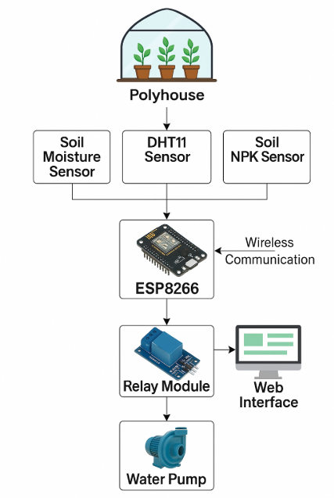Below Fig 3.1 is the architectural diagram representing the design of the Smart Polyhouse Irrigation Management System:

**Fig 3.1: System Architecture**

**3.3 Workflow of the System**

The workflow of the Smart Polyhouse Irrigation Management System outlines the sequence of operations that enable real-time monitoring and automation of irrigation processes in a controlled agricultural environment. The system begins with the initialization of the ESP8266 microcontroller upon power-on. Once active, the microcontroller collects data from various integrated sensors, including a soil moisture sensor, DHT11 sensor (for temperature and humidity), and an NPK sensor (for essential nutrient levels like Nitrogen, Phosphorus, and Potassium) as shown below in Fig 3.2.

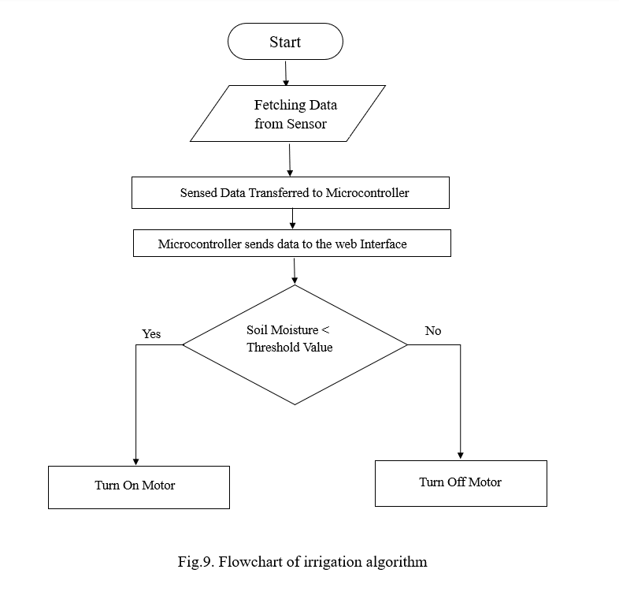

**Fig 3.2: Flow Diagram**

After gathering data, the ESP8266 processes the inputs and compares them against predefined thresholds that reflect optimal growing conditions. If the soil moisture level falls below the threshold, the system triggers the relay module to activate the water pump, thereby initiating irrigation. Similarly, if abnormal temperature, humidity, or nutrient levels

are detected, the system may alert the user or suggest corrective actions. All sensor readings and system actions are transmitted to the backend server using communication protocols such as HTTP or MQTT.

The backend then logs this data and makes it available to the user through a responsive web dashboard. Users can monitor live sensor readings, check motor status, and even manually override the pump operation if desired. This interaction ensures flexibility while maintaining a high level of automation. The system continuously loops through these steps, enabling intelligent, data-driven irrigation control, reducing resource waste, and enhancing crop productivity in the polyhouse.

**3.4 Methodology**

The methodology of the Smart Polyhouse Irrigation Management System involves a structured and integrated approach to automating irrigation in a polyhouse environment using IoT technology. The process begins with a thorough requirement analysis, identifying essential hardware such as the ESP8266 Node MCU microcontroller, soil moisture sensor, DHT11 sensor for temperature and humidity, NPK sensor for soil nutrients, and a relay module for water pump control. Software tools including Arduino IDE, Node.js (for backend development), and web technologies like HTML, CSS, and JavaScript (or React.js) are selected to support the system’s development.

The system design phase defines the overall architecture, outlining the interaction between hardware, backend logic, and frontend user interface. A workflow diagram is created to visualize the step-by-step functioning of the system from sensor data collection to automated decision-making and actuation. Following this, the microcontroller is programmed using C++ in the Arduino IDE to collect real-time data from the connected sensors and transmit it to the backend server via HTTP protocols.

The backend, developed in Node.js, processes the incoming data, compares it with predefined plant-specific thresholds, and stores the information in a cloud database like Firebase or MongoDB. It also handles user authentication and sends control commands to the microcontroller. The frontend web interface is designed to be responsive and user-

friendly, enabling users to monitor sensor values, control the motor, view plant health information, and manage access securely.

After development, each component undergoes rigorous testing and calibration to ensure the system performs accurately and reliably. The final deployment takes place in a real polyhouse setup, where the system is evaluated based on irrigation efficiency, ease of use, and environmental sustainability. This methodology ensures a practical, scalable, and smart solution for modern-day precision agriculture.

**3.5 Summary**

This chapter outlines the design and implementation of the Smart Polyhouse Irrigation Management System, which automates irrigation through the use of IoT technology. The system integrates sensors for monitoring soil moisture, temperature, humidity, and nutrient levels, providing real-time data to the microcontroller (ESP8266). This data is processed to trigger irrigation actions based on preset thresholds. The system is controlled via a web interface, enabling remote monitoring and management. This proposed system enhances resource efficiency, reduces manual labor, and ensures sustainable farming practices.

**CHAPTER 4**

**HARDWARE AND SOFTWARE REQUIREMENTS**

* 1. **Introduction**

This chapter provides a brief overview of the various hardware and software components essential for designing the Smart Polyhouse Irrigation Management System. The system integrates IoT technology for real-time monitoring and automation of irrigation processes within a controlled polyhouse environment. Using ESP8266 as the main microcontroller, along with sensors for soil moisture, temperature, humidity, and NPK levels, the hardware setup ensures accurate environmental data collection. The software stack, including tools for microcontroller programming, backend development, and frontend interface, enables seamless data processing, user interaction, and remote system control.

**4.2 Hardware Components**

**4.2.1 ESP8266 Microcontroller**

The ESP8266 microcontroller is the central processing unit of the Smart Polyhouse Irrigation Management System, acting as the brains behind the system’s operations. This low-cost, Wi-Fi-enabled microcontroller is specifically designed for Internet of Things (IoT) applications, making it an ideal component for remote monitoring, automation, and real-time data transmission. The ESP8266 gathers data from various sensors, including soil moisture sensors, NPK sensors, and temperature and humidity sensors, and then uses its integrated Wi-Fi module to send this information to a web-based platform or cloud-based server. This capability allows farmers to remotely monitor and control irrigation settings, ensuring that crops receive optimal water and nutrients without the need for manual intervention. The ESP8266 microcontroller is a compact, credit card-sized device, measuring approximately 25.5mm in width below Fig 4.1 shows the ESP8266 microcontroller

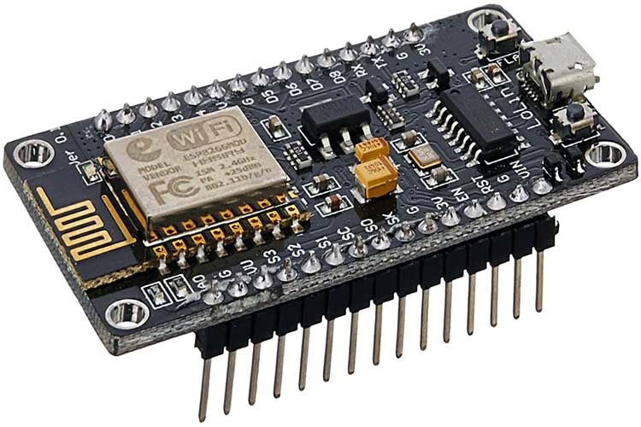

**Fig 4.1: ESP8266 Microcontroller**

One of the key advantages of the ESP8266 is its low power consumption, which makes it an energy-efficient choice for continuous operation in polyhouse farming systems. It operates at 3.3V, with an input voltage range of 7-12V, ensuring that it remains functional

even in environments where power resources are limited. This low energy requirement is particularly important for agriculture-based IoT applications, where devices need to function round the clock without consuming excessive power. Additionally, the compact size of the ESP8266 makes it highly versatile, allowing it to be integrated into small-scale and large-scale automated farming systems with ease.

The ESP8266 is known for its versatility and ease of programming, making it accessible to both beginner and expert developers. It is compatible with popular programming environments such as the Arduino IDE, enabling users to create custom automation scripts tailored to their specific agricultural needs. The microcontroller supports multiple communication protocols, including I2C, UART, and SPI, allowing seamless connectivity with a wide range of sensors and actuators. This flexibility makes it suitable for complex automation systems, where multiple devices need to work together to achieve efficient irrigation management.

With a 32-bit microcontroller architecture, the ESP8266 offers high-speed processing capabilities, enabling it to analyse sensor data and make instant irrigation decisions. When the system detects that soil moisture levels have dropped below the predefined threshold, the ESP8266 signals the relay module to activate the water pump, ensuring that crops receive adequate irrigation. Similarly, when NPK sensors detect

nutrient deficiencies, the system can either alert farmers through the web interface or trigger an automated fertilization process, maintaining optimal soil conditions for plant growth.

The ESP8266's wireless connectivity features make it an essential component in modern precision agriculture. By enabling seamless cloud integration, it allows farmers to monitor polyhouse conditions in real-time, regardless of their location. This enhances efficiency, reduces water and nutrient wastage, and improves overall crop productivity. With its low cost, energy efficiency, programmability, and wireless capabilities, the ESP8266 plays a crucial role in transforming traditional farming into a smart, automated, and data-driven agricultural system.

**4.2.2 Arduino UNO**

The Arduino UNO is a popular open-source microcontroller board based on the ATmega328P chip. It's used for building electronics projects and can read inputs (like sensors) and control outputs (like LEDs or motors). It connects to a computer via USB for programming using the Arduino IDE. It's beginner-friendly and widely supported as shown below in Fig 4.2.

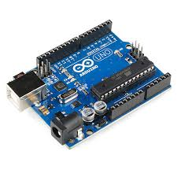

**Fig 4.2: Arduino UNO Board**

In this project, the Arduino Uno serves a crucial role in managing the operation of the relay module, which acts as an electrical switch to control the irrigation motor (water pump). While the ESP8266 NodeMCU handles the data processing, sensor interfacing, and

decision-making logic, the Arduino Uno is dedicated to executing the physical switching action. This is especially important because the relay module requires a higher current than what the ESP8266 can safely handle directly. By using the Arduino Uno as an intermediary, the system ensures reliable switching without compromising the safety or functionality of the microcontroller.

Communication between the ESP8266 and Arduino Uno is established through digital I/O pins or serial communication protocols such as UART. When the ESP8266 detects, through its connected sensors (soil moisture, temperature, humidity, and NPK), that the environmental conditions require irrigation, it sends a control signal to the Arduino. The Arduino, upon receiving this instruction, triggers the relay module to turn on the motor and initiate watering. Once the moisture level reaches the optimal value, the ESP8266 sends another signal to turn off the motor, and the Arduino responds by deactivating the relay.

This architecture not only enhances the robustness of the system but also allows for modular design and load isolation. The use of Arduino Uno to manage the relay ensures that high-current loads do not interfere with the sensitive operation of the ESP8266, improving system safety and longevity.

**4.2.3 Soil Moisture Sensor**

The soil moisture sensor is a crucial component in precision farming and smart irrigation systems, as it plays a vital role in detecting the volumetric water content of the soil. This real-time monitoring capability allows for efficient water management, ensuring that crops receive the right amount of water at the right time. The sensor operates using either resistive or capacitive technology below Fig 4.3 shows the Soil moisture sensor

In resistive sensors, two electrodes are inserted into the soil, and the electrical resistance between them varies based on the soil’s moisture content. When the soil is dry, resistance is high, whereas in moist soil, resistance decreases due to increased conductivity. On the other hand, capacitive soil moisture sensors measure changes in the dielectric constant of the soil, which shifts as the moisture content fluctuates. Capacitive

sensors are often preferred for their durability and resistance to corrosion, making them suitable for long-term agricultural use.

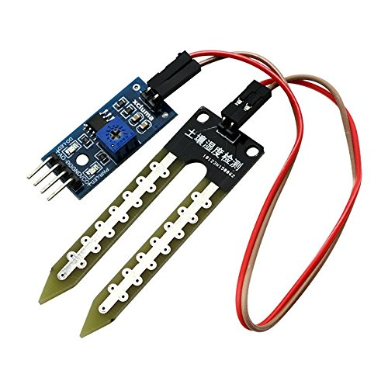

**Fig 4.3: Soil moisture sensor**

The real-time data collected by the soil moisture sensor is crucial for the automation of irrigation systems. When the sensor detects that soil moisture levels have dropped below a predefined threshold, it triggers the irrigation system to activate the water pump, supplying water to the crops. Once the soil moisture reaches an optimal level, the system turns off the pump, thereby preventing over-irrigation and water wastage. This automated response ensures that crops receive a consistent supply of water, leading to healthier plant growth and higher agricultural productivity.

By integrating soil moisture sensors into smart irrigation systems, farmers can significantly conserve water, reduce manual labour, and optimize resource utilization. This technology plays a key role in sustainable farming, helping to balance water efficiency, environmental conservation, and crop yield improvement.

**4.2.4 DHT11 Sensor (Temperature and Humidity Sensor)**

The DHT11 sensor is a low-cost digital sensor designed for measuring temperature and humidity as shown in , making it a vital component in smart farming and environmental monitoring applications. Due to its single-wire communication protocol, it can be easily integrated with microcontrollers such as the ESP8266, allowing for seamless data collection and automation. The DHT11 operates within a humidity range of 20% to 80%,

with an accuracy of ±5% relative humidity, and measures temperatures from 0°C to 50°C with a precision of ±2°C. While it is not the most precise sensor available, its affordability, compact size, and low power consumption make it an excellent choice for automated systems that require real-time climate monitoring below Fig 4.4 shows the DHT11 sensor.

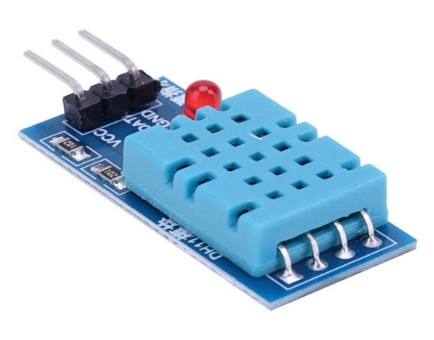

**Fig 4.4: DHT11 sensor**

In a Smart Polyhouse Irrigation Management System, the DHT11 sensor plays a crucial role in monitoring the microclimate, ensuring that optimal growing conditions are maintained for plants. Temperature and humidity are key environmental factors that directly influence plant health, growth rate, and water requirements. If temperature levels rise above optimal thresholds, the system can adjust irrigation schedules or activate cooling mechanisms, such as ventilation fans or misting systems, to maintain a stable environment. Similarly, humidity readings help in regulating irrigation cycles, ensuring that plants receive the appropriate moisture levels without the risk of overwatering or excessive dryness.

The real-time data provided by the DHT11 sensor allows for automated adjustments in irrigation and environmental control systems, reducing manual intervention while enhancing efficiency. By continuously monitoring temperature and humidity, farmers can optimize crop yields, reduce resource wastage, and create a stable growing environment. The sensor’s integration into smart farming solutions ensures that plants receive the best possible conditions, ultimately leading to improved crop quality and higher agricultural productivity.

**4.2.5 Soil NPK Level Sensor**

The Soil NPK Level Sensor plays a critical role in precision farming by providing real-time data on the levels of three essential nutrients nitrogen (N), phosphorus (P), and potassium (K) in the soil. These nutrients are vital for plant growth, influencing processes such as root development, flowering, and overall crop yield. The sensor uses advanced techniques like capacitive sensing or electrochemical principles to measure the nutrient content in the soil accurately. By integrating this data into a Smart Polyhouse Irrigation Management System, the sensor enables farmers to monitor soil fertility continuously and manage nutrient levels effectively. The real-time data provided by the sensor is sent to a microcontroller, which processes it and determines if any adjustments are necessary for optimal plant growth. If nutrient levels fall below the ideal threshold, the system can trigger automated actions such as nutrient replenishment or adjustments to the irrigation practices, ensuring that plants receive the right balance of nutrients at all times

This ability to respond to nutrient imbalances automatically is essential for promoting sustainable farming practices. It helps prevent overfertilization, which can lead to environmental degradation through runoff and contamination of water bodies. By maintaining the proper nutrient levels, the sensor not only supports healthy plant growth but also reduces the need for excessive chemical fertilizers, thereby minimizing the environmental impact. Additionally, this technology encourages more efficient use of resources, as it ensures that nutrients and water are applied only when and where needed.

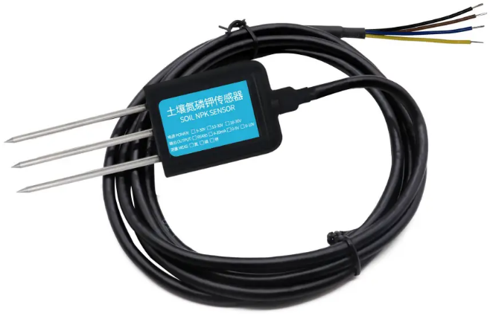below Fig 4.5 shows the Soil NPK Level sensor.

**Fig 4.5: Soil NPK Level sensor**

In this way, the Soil NPK Level Sensor enhances the productivity and sustainability of farming practices. As part of a Smart Polyhouse system, it optimizes nutrient and irrigation management, ensuring that crops thrive while reducing waste and environmental harm, making it an indispensable tool for modern, environmentally-conscious farming.

**4.2.6 Relay Module**

In the Smart Polyhouse Irrigation Management System, the relay module serves as a crucial component that bridges the gap between low-power control circuits and high-power devices like water pumps. By utilizing a relay, the system can manage the activation and deactivation of the water pump through low-voltage signals from a microcontroller, such as the ESP8266, without the need for direct electrical connections to the high-voltage pump circuitry. This design approach enhances safety by electrically isolating the control and power circuits, protecting sensitive components from potential electrical hazards.

The relay module functions by receiving control signals informed by real-time data from various environmental sensors, including soil moisture sensors. When the soil moisture level falls below a predefined threshold, indicating that the soil is dry, the system triggers the relay to activate the water pump. This action initiates irrigation, delivering water to the plants to restore optimal moisture levels. Conversely, when the soil reaches an adequate moisture level, the system deactivates the relay, turning off the pump and halting irrigation. This automated process ensures that plants receive consistent and appropriate watering, promoting healthy growth while conserving water resources below Fig 4.6 shows the Relay module.

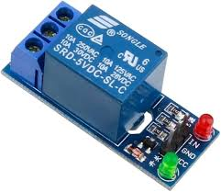

**Fig 4.6: Relay module**

By incorporating the relay module, the system effectively separates the high-voltage operations of the water pump from the low-voltage control circuitry. This separation not only safeguards the microcontroller and associated components but also

allows for greater flexibility in system design. For instance, different relay modules can be selected based on the specific voltage and current requirements of various pumps, accommodating diverse irrigation needs. Additionally, the use of relays facilitates the integration of multiple pumps or other high-power devices, each controlled independently by the microcontroller, thereby enhancing the system's scalability and adaptability.

**4.2.7 Water Pump**

The Smart Polyhouse Irrigation Management System incorporates a highly efficient and automated water pump mechanism, which plays a crucial role in ensuring optimal water supply to plants based on their actual moisture requirements. This system employs an electric pump that facilitates the movement of water from a designated source, such as a well or a water storage tank, directly to the irrigation system. By integrating advanced automation technology, the system minimizes human intervention while ensuring precision irrigation. The pump is controlled by a relay module, which acts as an intermediary between the microcontroller and the pump itself. Specifically, the ESP8266 microcontroller is responsible for monitoring soil moisture levels through specialized sensors placed within the polyhouse. These soil moisture sensors continuously assess the water content in the soil and transmit real-time data to the microcontroller. When the moisture levels drop below a predefined threshold, the ESP8266 triggers the relay module, activating the water pump. This automatic activation ensures that plants receive the necessary amount of water precisely when needed, preventing under-irrigation, which can hinder plant growth below Fig 4.7 shows the Water pump.

Furthermore, the automated nature of the system plays a significant role in water conservation by preventing excessive irrigation. Over-irrigation not only wastes valuable water resources but can also negatively impact plant health by causing root rot, nutrient leaching, or soil degradation. By leveraging real-time data processing and intelligent decision-making, the system optimizes water usage, thereby enhancing both plant growth and sustainability. The controlled environment of a polyhouse demands a highly efficient irrigation process to maintain stable growing conditions, and the dependability of the water pump is a critical factor in achieving this goal. The pump's efficiency directly influences the system’s performance, as any malfunction or inefficiency could result in inadequate hydration for the plants, potentially affecting overall yield and productivity.

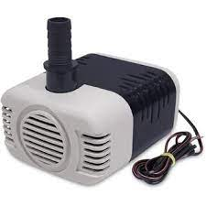

**Fig 4.7: Water pump**

In addition to conserving water, the system reduces labour costs and enhances agricultural productivity by providing precise irrigation without the need for constant manual monitoring. This integration of smart technology in irrigation management significantly contributes to sustainable farming practices, allowing farmers to achieve higher yields with lower resource consumption. By ensuring a consistent and optimal water supply, the Smart Polyhouse Irrigation Management System enhances the overall health, development, and productivity of plants while promoting eco-friendly agricultural practices.

**4.2.8 Jumper Wire**

Jumper wires are shown in Fig 4.8 are essential components in electronics prototyping and circuitry, serving as flexible connectors to establish electrical connections between various components on a breadboard or their prototyping platforms, these wires typically consist of thin, flexible cables with connectors, such as male or female headers, at each end, allowing them to be easily inserted into and removed from the terminals of electronic components.

Key characteristics and uses of jumper wires include:

* Flexibility: Jumpers wires are highly flexible, allowing them to be bent and maneuverer into different positions on a breadboard or circuit layout to establish connections between components.
* Versatility: They come in various lengths, colours, and connector types, providing versatility in creating custom wiring configurations for different projects and applications.
* Convenience: Jumpers wires eliminate the need for soldering connections, enabling rapid prototyping and experimentation without the need for specialized tools or equipment.
* Temporary connections: They are ideal for creating temporary connections during prototyping and testing phases of electronics projects, allowing for easy modification and iteration of circuit designs.
* Breadboarding: Jumpers wires are commonly used in conjunction with breadboards to create temporary circuits for testing and validation purposes before finalizing a design for soldering onto a PCB (Printed Circuit Board).
* Troubleshooting: They facilitate easy troubleshooting by enabling engineers and hobbyists to quickly rearrange connections or isolate components to identify and rectify issues in the circuit.

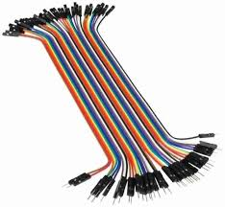

**Fig 4.8: Jumper Wire**

**4.2.9 Bread Board**

A breadboard shown in Fig 4.9 is a tool used for prototyping electronic circuits without soldering. It has a grid of holes where components like resistors, capacitors, and microchips are inserted, and internal connections allow easy wiring of circuits. Power rails on the sides distribute power, typically labeled with "+" and "-" for positive and negative connections. The central area, called the terminal strip, provides rows for inserting components and making electrical connections.

Breadboards are reusable, flexible, and great for testing and modifying circuits. They are ideal for building and debugging small to medium-sized circuits, especially in educational settings or during the initial phases of product development. Users can easily rearrange components, add or remove parts, and change the configuration without soldering, making them perfect for experimentation.

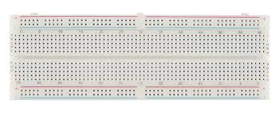

**Fig 4.9: Bread Board**

These are especially useful for low-power and low-frequency circuits, such as simple logic gates, sensors, and microcontroller projects. However, they are not suitable for high-current circuits or high-frequency applications due to the potential for poor connections, interference, and power loss.

* 1. **Software Requirements**
     1. **Microcontroller Programming Tool (Arduino IDE):**

The Arduino IDE is a beginner-friendly integrated development environment that supports programming microcontrollers like the ESP8266 NodeMCU, making it well-suited for projects such as the Smart Polyhouse Irrigation Management System. It provides a simple and intuitive platform for writing, uploading, and debugging code written in C/C++, as shown in Fig 4.9.

One of the main advantages of the Arduino IDE is its widespread support for various microcontrollers and its compatibility with a broad range of community-contributed libraries. For the ESP8266, it allows seamless integration after installing the appropriate board support package through the Board Manager. This enables developers to write efficient firmware that can interface with sensors and modules used in Smart Polyhouse applications.

The Arduino IDE makes it easy to work with critical sensors used in the Smart Polyhouse project. It supports integration with devices such as the DHT11 sensor for temperature and humidity monitoring, soil moisture sensors to measure water content, and NPK sensors for analysing essential soil nutrients like Nitrogen (N), Phosphorus (P), and Potassium (K). Libraries for these sensors are readily available and can be installed directly through the Library Manager, streamlining the coding process for sensor data acquisition and analysis.

A notable feature of the Arduino IDE is its built-in support for serial communication through the Serial Monitor, which allows real-time debugging and monitoring of data from the microcontroller. This is especially useful for verifying sensor readings, checking system responses, and ensuring the correct behaviour of control logic in the irrigation system.

The IDE also supports direct uploading of code to the ESP8266 via USB, eliminating the need for external flashing tools. Additionally, developers can organize

their code using modular sketches, and manage different versions or configurations of the irrigation control logic easily.

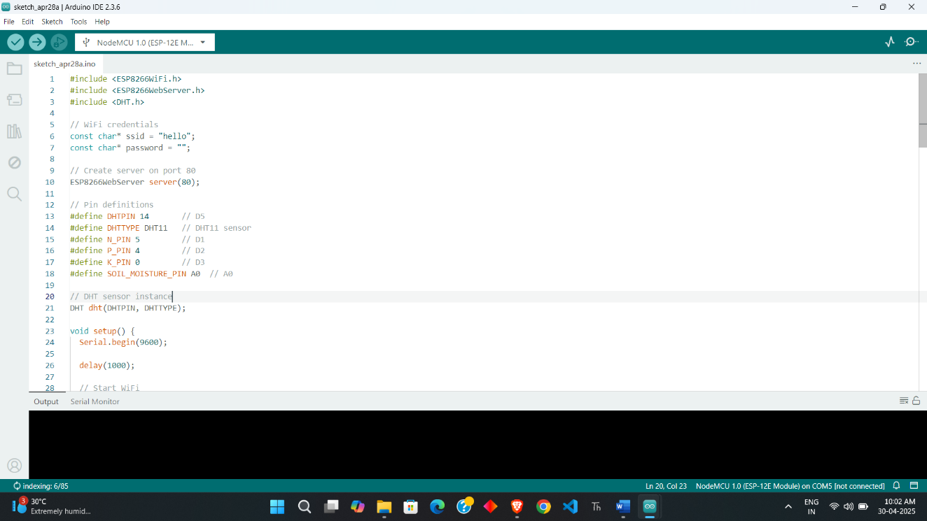Another powerful feature is the use of Serial Plotter, which provides a graphical view of real-time data, useful for visualizing trends in temperature, humidity, or soil moisture. Combined with a vast community and rich documentation, the Arduino IDE offers a practical, reliable, and efficient development environment for IoT applications such as the Smart Polyhouse Irrigation Management System.

**Fig 4.9:Arduino IDE Software**

* + 1. **Node.js (for Backend)**

The backend for the Smart Polyhouse Irrigation Management System is responsible for managing the core logic, data flow, device communication, and user interactions. A robust and scalable backend ensures seamless connectivity between the microcontroller (ESP8266), the database, and the frontend interface.

The backend is primarily built using Node.js, owing to its event-driven, non-blocking I/O model, which makes it ideal for handling real-time sensor data and controlling irrigation devices. Alternatively, backend frameworks such as Flask (Python)

or PHP can be used based on developer preference or compatibility with existing systems.

To maintain fast and reliable communication between the microcontroller, actuators, and the frontend web application, the backend uses protocols like HTTP and MQTT. MQTT is especially beneficial in IoT environments due to its lightweight structure and minimal bandwidth usage. Security is another important focus; the backend implements robust access control mechanisms such as token-based authentication (JWT) and session management, ensuring that only authorized users can interact with devices or access sensitive plant data.

* + 1. **Visual Studio Code (VS Code)**

Visual Studio Code (VS Code) is the best code editor for front-end and back-end development of the Smart Polyhouse Irrigation Management System project. In order to create the web interface that enables users to monitor sensor data, regulate irrigation, and observe real-time system status, Visual Studio Code offers frontend development standards including HTML, CSS, and JavaScript. Developers may evaluate web pages in real time using extensions like Live Server, making sure that the user interface components are responsive and shown correctly on all devices. The development process is improved by the editor's IntelliSense and error-checking capabilities, which make it simpler to generate clear, error-free code as shown below in Fig 4.10.

For the backend development, VS Code integrates seamlessly with Node.js, which is used for handling API logic and communication with the microcontroller (ESP8266). The editor supports JavaScript and JSON, making it suitable for handling sensor data, triggering control signals, and managing database connections. With built-in support for Git, VS Code facilitates version control, allowing for better code management and collaboration. Moreover, the integrated terminal allows developers to execute backend scripts, run servers, and test the system's functionalities without leaving the editor.

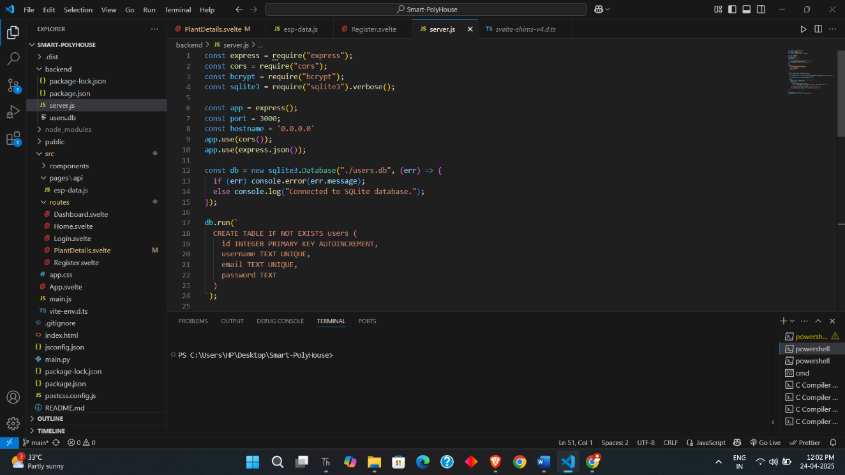

**Fig 4.10: Visual Studio Code**

**4.3.4 GitHub**

GitHub shown in Fig 4.11 not only supports version control and collaboration but also integrates powerful project management features, which are essential for keeping the Smart Polyhouse Irrigation Management System on track. Through GitHub Issues, project members can log tasks, bugs, and enhancements, and assign them to specific team members. This feature helps keep everyone organized and ensures that no aspect of the project is overlooked. Additionally, GitHub provides a detailed history of the project’s development, allowing team members to easily review past changes, roll back to previous versions if necessary, and understand the evolution of the system.

GitHub’s Pull Request (PR) feature enables code review before new changes are merged into the main codebase, ensuring that all updates are thoroughly vetted for quality, security, and performance. The use of PRs facilitates collaboration, as developers can leave comments on specific lines of code, suggest improvements, and discuss potential issues, promoting best practices in software development.

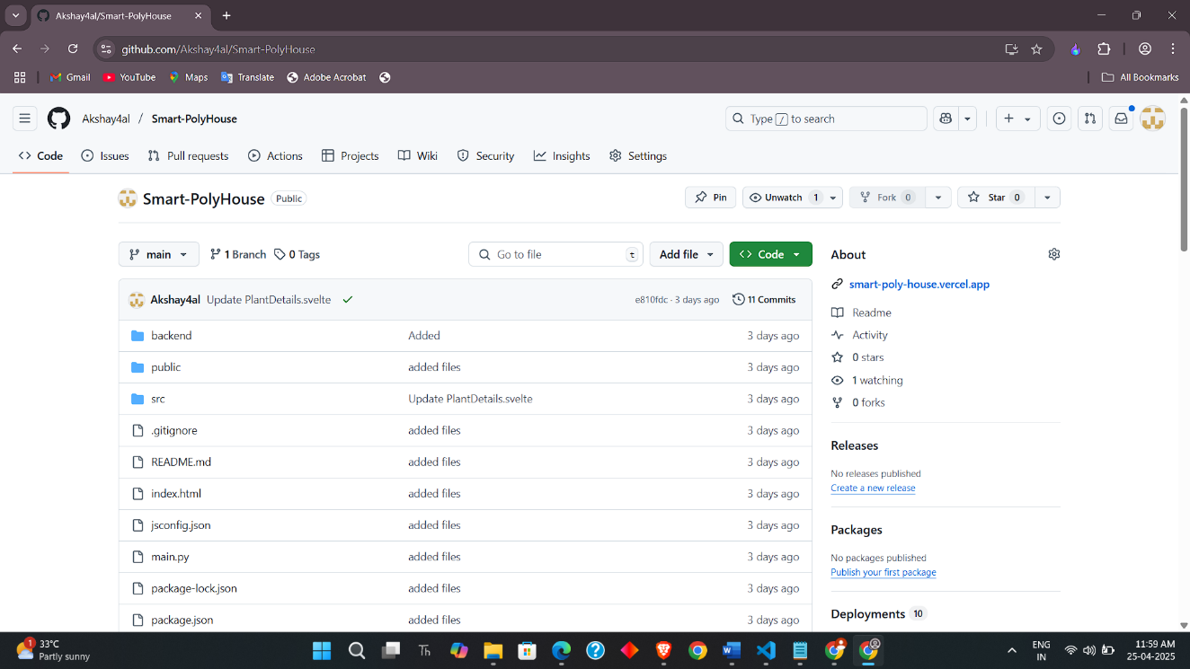

**Fig 4.11: GitHub**

GitHub also integrates seamlessly with various development tools, making it easier to link the repository with other parts of the development pipeline, such as task management systems (like Trello or Jira) and cloud platforms. For our project, this integration allows for smooth deployment to cloud services for real-time monitoring and control of irrigation, ensuring that the Smart Polyhouse Irrigation Management System runs efficiently in a live environment. Additionally, GitHub Pages can be used to host documentation or an API interface, making the project more accessible to external stakeholders, such as agricultural experts, other developers, or even farmers who may want to contribute.

Ultimately, GitHub enhances collaboration, improves code quality, and ensures that the Smart Polyhouse Irrigation Management System can evolve continuously and adapt to new technological advancements and user requirements. Through effective version control, code reviews, and project management, GitHub plays an integral role in the overall development, deployment, and maintenance of the system.

**CHAPTER 5**

**HARDWARE IMPLEMENTATION**

**5.1 Introduction**

This chapter presents the detailed hardware implementation of the Smart Polyhouse Irrigation Management System. It outlines the physical components used such as sensors, microcontrollers, relays, and actuators and explains their integration and functionality within the system. The chapter also describes how these components work together to enable automated irrigation, real-time environmental monitoring, and efficient resource utilization in a controlled polyhouse environment.

**5.2 Mechanism of Soil Moisture Sensor**

The soil moisture sensor in the Smart Polyhouse Irrigation Management System consists of two conductive probes, typically made of metal, which are inserted into the soil. These probes act as electrodes as shown in Fig 5.1 to measure the resistance between them, and this resistance varies depending on the moisture content in the soil. In dry soil, the low water content results in higher resistance between the probes, leading to low conductivity and a lower output signal. Conversely, in moist soil, the increased water content reduces the resistance, enhancing conductivity and generating a higher output signal. The sensor provides either an analog voltage, which corresponds to the moisture content, or a digital HIGH/LOW signal that indicates whether the soil is dry or moist above a set threshold.

The analog signal is read by the ESP8266 NodeMCU, which processes the data to determine the moisture level. If the soil moisture is above the preset threshold, indicating sufficient moisture, the system keeps the water pump OFF. However, when the moisture level falls below the threshold, indicating dry soil, the ESP8266 triggers a relay module to turn ON the water pump for irrigation. Once the soil moisture is restored to the desired level, the system automatically turns off the pump. The sensor continuously monitors the moisture levels and sends data at regular intervals to the ESP8266, allowing the system

to make real-time irrigation decisions and maintain optimal moisture for the plants. This continuous monitoring ensures efficient water usage and helps maintain ideal growing conditions.

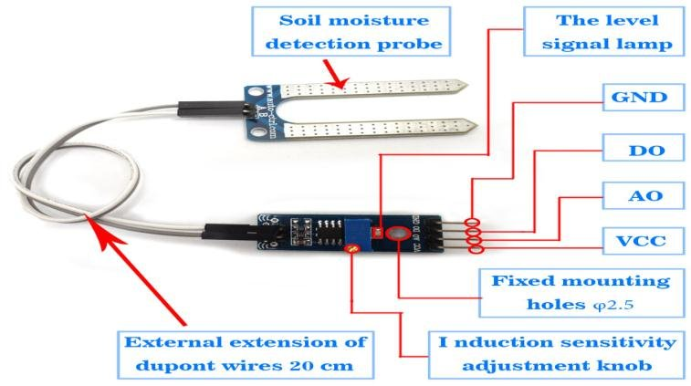

**Fig 5.1: Soil Moisture Sensor**

* 1. **Mechanism of DHT11 Sensor**

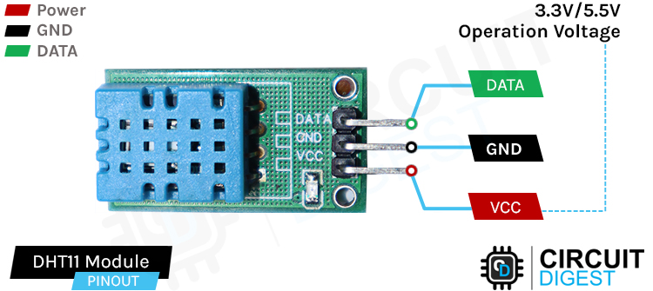The DHT11 sensor is a crucial component of the Smart Polyhouse Irrigation Management System, providing real-time data on temperature and humidity, two critical factors for maintaining optimal growing conditions shown in Fig 5.2. The sensor integrates a thermistor to measure temperature and a moisture-sensitive substrate for humidity detection. The thermistor’s resistance varies with temperature, and the humidity component’s conductivity changes based on moisture levels in the air. These changes are processed by the sensor and converted into a calibrated digital signal, which is transmitted to the ESP8266 NodeMCU via a single-wire protocol. This minimizes pin usage and simplifies integration with the microcontroller, making it ideal for efficient system design.

**Fig 5.2: DHT11 Sensor**

The DHT11 sensor’s role in the Smart Polyhouse Irrigation Management System extends beyond simple monitoring. In this system, the sensor is strategically placed within the polyhouse to continuously monitor internal temperature and humidity, which are crucial for plant health. By providing continuous environmental data, it helps assess plant stress levels, such as excessive heat or low humidity that may accelerate moisture evaporation from the soil. These conditions may trigger the system to adjust irrigation schedules or activate alerts. Furthermore, the sensor’s ability to log historical data allows for trend analysis, which enables the optimization of the polyhouse environment over time. This analysis helps improve future system performance, refine crop cycle planning, and ensures better water management and resource conservation, ultimately contributing to enhanced crop productivity and sustainable farming practices.

* 1. **Mechanism of NPK Sensor**

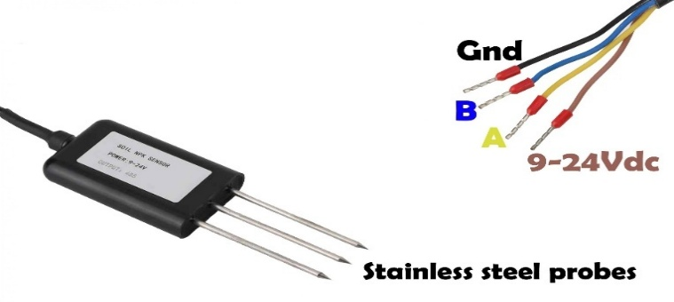The NPK sensor works by utilizing electrochemical sensors to measure the concentration of Nitrogen (N), Phosphorus (P), and Potassium (K) ions in the soil or nutrient solution. Each of these ions carries a specific electrical charge, which is detected by the sensor. The sensor shown in Fig 5.3 is equipped with electrodes coated with materials selective for detecting the ions of each nutrient. When the sensor is placed in the soil or solution, the ions react with the electrode surface, generating a voltage or current proportional to the ion concentration. The sensor then processes this signal, converting it into a measurable output, either analog or digital, depending on its design. The processed data is sent to the microcontroller, such as the ESP8266 NodeMCU, which interprets the nutrient levels by comparing them to predefined thresholds set within the system. If the nutrient levels are outside the optimal range, the system may trigger an alert or automatically adjust the irrigation or fertilization processes to restore the nutrient balance. This mechanism ensures that the plants receive the proper nutrients for healthy growth and optimal yield.

**Fig 5.3: NPK Sensor**

**5.5 Operation of Relay Module**

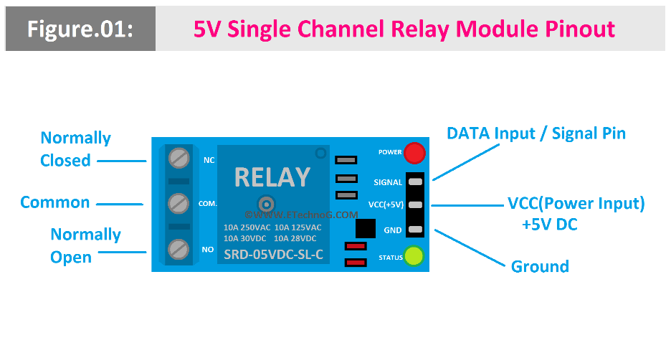The relay module in the Smart Polyhouse Irrigation Management System serves as an essential switching device that controls the operation of high-power components, specifically the water pump, based on input signals from the microcontroller (ESP8266 NodeMCU). It acts as a bridge between the low-voltage control circuit and the high-voltage operational equipment.

**Fig 5.4: Relay Module**

The working mechanism of the relay module as shown in above Fig 5.4 begins when the ESP8266 receives input from the soil moisture sensor. If the soil moisture level is below the predefined threshold, the microcontroller sends a low-voltage signal to the relay module. This signal energizes the internal coil of the relay, creating a magnetic field that pulls the switch inside the relay to the closed position. As a result, the circuit connected to the water pump is completed, and the pump is turned ON to irrigate the plants.

Once the soil moisture reaches an optimal level, the ESP8266 cuts off the signal to the relay, causing the internal switch to return to its normally open state. This breaks the circuit, and the pump is turned OFF automatically. This mechanism allows safe and automatic control of the water pump without manual intervention, ensuring efficient irrigation based on real-time sensor data while protecting low-power components from high-voltage currents.

**5.6 Operation of Water Pump**

In the Smart Polyhouse Irrigation Management System, the water pump plays a critical role in delivering water to the plants based on real-time soil moisture conditions. Its operation is fully automated and controlled through the ESP8266 NodeMCU and relay module.

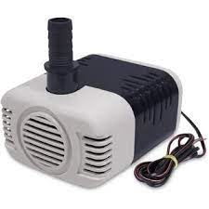The working mechanism begins when the soil moisture sensor detects that the moisture level in the soil has dropped below a predefined threshold. This information is sent to the ESP8266 microcontroller, which processes the data and activates the relay module. The relay, acting as a switch, completes the electrical circuit and supplies power to the water pump, turning it ON.

**Fig 5.5: Water Pump**

Once activated, the water pump as shown in above Fig 5.5 draws water from a reservoir or water source and delivers it to the plant beds through connected irrigation pipes or drip lines, ensuring uniform and timely watering. As the soil absorbs the water and moisture levels rise, the soil moisture sensor continuously sends updated readings to the ESP8266.When the soil moisture reaches the optimal level, the ESP8266 deactivates the relay, which in turn cuts off the power to the water pump, turning it OFF. This mechanism ensures that the plants receive just the right amount of water, preventing over-irrigation or water wastage. The automation not only conserves water but also reduces manual labour and enhances the overall efficiency of the irrigation process.

**5.7 Sensors Interfacing**

In the Smart Polyhouse Irrigation Management System, various sensors are interfaced shown in Fig 5.6 with the ESP8266 NodeMCU to monitor environmental and soil parameters essential for plant growth. The soil moisture sensor is connected to the analog input pin (A0) of the ESP8266. It operates by measuring the resistance between two probes inserted into the soil, where the resistance changes depending on the moisture content. This sensor provides an analog voltage that is interpreted by the microcontroller to determine the percentage of soil moisture.

The DHT11 sensor, which monitors temperature and humidity, is connected to a digital pin (GPIO14 or D5) of the ESP8266. It contains a thermistor for temperature measurement and a humidity-sensitive substrate for detecting atmospheric moisture. The sensor outputs digital, calibrated temperature and humidity data through a single-wire communication protocol, making it efficient and easy to interface.

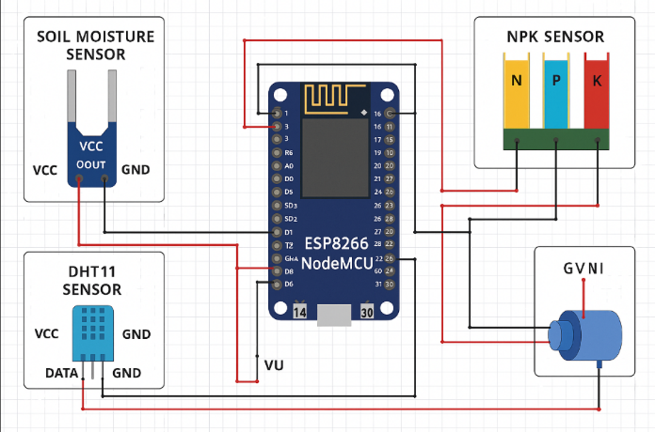The NPK sensor, responsible for detecting the concentration levels of nitrogen (N), phosphorus (P), and potassium (K), uses three separate digital input pins on the ESP8266—GPIO5 (D1) for nitrogen, GPIO4 (D2) for phosphorus, and GPIO0 (D3) for potassium. These sensors detect the presence of specific ions in the soil and provide a digital HIGH or LOW signal depending on the sufficiency of each nutrient. The ESP8266 processes these signals to assess nutrient levels, allowing the system to inform the user or adjust fertilization practices if required.

**Fig 5.6 Sensor Interfacing**

**CHAPTER 6**

**SOFTWARE IMPLEMENTATION**

* 1. **Introduction**

This chapter describes the coding and software configuration used to operate the Smart Polyhouse Irrigation Management System. It covers the programming of the ESP8266 NodeMCU for reading data from sensors such as soil moisture, temperature, humidity, and NPK, and making decisions for irrigation automation. The chapter also explains the development of the web interface for real-time monitoring and control, ensuring efficient system performance and user interaction.

* 1. **Microcontroller:**

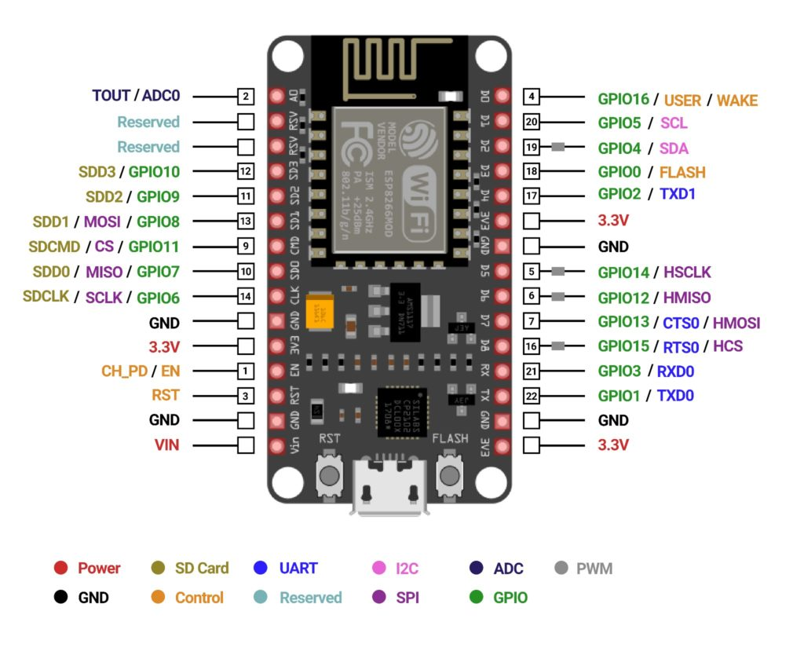The ESP8266 NodeMCU (Micro Controller Unit) serves as the core processing unit of the system. It is a low-cost, Wi-Fi-enabled microcontroller that offers excellent support for IoT-based applications. The microcontroller is programmed using the Arduino IDE, which allows easy integration of sensor libraries and network communication protocols. The ESP8266 shown in below Fig 6.1 reads analog and digital signals from connected sensors, preprocesses the data, and manages communication with cloud or web-based services.

**Fig 6.1: ESP8266**

* + 1. **Sensor Integration:**

The system is equipped with a variety of sensors to collect real-time data on essential plant growth parameters:

* **Soil Moisture Sensors:** These detect the volumetric water content in soil. They help determine if irrigation is necessary based on soil dryness or saturation levels.
* **DHT11 Sensor:** This digital sensor measures ambient temperature and humidity within the polyhouse. Maintaining optimal environmental conditions is crucial for healthy plant development and disease prevention.
* **NPK Sensor:** This sensor detects the concentrations of Nitrogen (N), Phosphorus (P), and Potassium (K) in the soil. These macronutrients are vital for plant nutrition, and the data helps determine whether fertilization is required.
  + 1. **Actuation Control:**

In this system, the relay module is connected to the Arduino Uno, which is responsible for controlling the switching operation of the water pump. The Arduino Uno itself operates based on signals received from the ESP8266 NodeMCU, which monitors real-time sensor data such as soil moisture and nutrient levels. When the ESP8266 detects that these parameters fall below the defined thresholds, it sends a control signal to the Arduino Uno. Upon receiving this signal, the Arduino triggers the relay module to turn on the irrigation motor. Similarly, when optimal conditions are restored, the ESP8266 sends another signal instructing the Arduino to switch off the motor. This setup allows for both automated control and potential manual override, ensuring efficient irrigation management through coordinated communication between the ESP8266 and Arduino Uno.

* + 1. **Data Transmission:**

The microcontroller uses built-in Wi-Fi to send sensor data to the backend using protocols such as:

* HTTP for RESTful communication.
* MQTT for lightweight, publish-subscribe messaging, ideal for real-time applications.
* Firebase Realtime Database or IoT cloud platforms to log and sync data instantly across user interfaces.
  1. **Communication and Backend**

This layer is at the heart of the Smart Polyhouse Irrigation Management System's software architecture. It serves as the central decision-making unit, facilitating seamless interaction between the physical devices (sensors and actuators) and the user-facing applications. It is responsible for processing incoming sensor data, applying logic to assess current conditions, and communicating appropriate responses back to the hardware or user interface.

* + 1. **Backend Functions and Responsibilities**

In the Smart Polyhouse Irrigation Management System, the backend plays a crucial role in processing sensor data, making decisions for irrigation and nutrient supplementation, and communicating with the user interface. The core responsibilities of the backend include:

* Receiving and Processing Sensor Data: The ESP8266 sends sensor data (such as soil moisture, temperature, humidity, and NPK levels) through HTTP requests to the backend, which processes the incoming data in JSON format. This data is captured by the server and prepared for analysis.
* Analyzing Sensor Data: The backend evaluates the real-time values from the soil moisture sensor, DHT11 sensor, and NPK sensor against predefined threshold

values for optimal plant growth. These thresholds are stored in a database and can be adjusted as needed for different plant types or growth stages.

* Decision-Making and Automation: Based on the sensor data analysis, the backend determines whether irrigation or nutrient supplementation is needed. If the soil moisture is low or the plant needs additional nutrients, the backend sends a command to activate the water pump or control other connected devices like the relay module to ensure optimal growing conditions.
* Real-Time Data Distribution: The backend ensures real-time updates of the system’s status, such as environmental conditions and irrigation status, to the frontend. This is achieved through real-time communication methods like Firebase or WebSockets, allowing users to monitor and control the system remotely without the need for manual refresh.

**6.3.2 Cloud Integration and Database Functions:**

The backend connects to a database or cloud storage solution to manage system-wide data persistently. When using Node.js, for example, a NoSQL solution like Firebase Realtime Database or MongoDB can be employed for high-speed read/write operations.

Key data components stored and retrieved by the backend include:

* Plant Profiles and Thresholds: Contains species-specific optimal conditions (moisture, temperature, NPK) for decision-making.
* Live Sensor Values: Continuously updated to reflect the current environmental conditions inside the polyhouse.
* Irrigation and Fertilization Logs: Tracks when and how long irrigation systems were active, aiding in analysis and reporting.
* User Credentials and Role Management: Ensures that access is restricted to authenticated users only, with different roles (admin, user, viewer) if needed.
* System Configuration Settings: Allows remote customization of control logic such as irrigation timing windows, sensor calibration values, and alert thresholds.

**6.4 Frontend Interface Layer (User Interaction)**

The Frontend Interface Layer serves as the primary point of interaction between the user and the Smart Polyhouse Irrigation Management System. It is carefully designed to provide a seamless, engaging, and functional experience that allows users to monitor real-time environmental data, search for plant-specific conditions, and control irrigation systems from any device. This layer is built to ensure both accessibility and usability, supporting informed agricultural decision-making.

**6.4.1 Web Interface :**

The user interface as shown in Fig 6.2 is developed using a combination of HTML, CSS, and JavaScript, with the option of integrating advanced frontend libraries such as React.js for enhanced performance, reactivity, and modular development.

The software interface for the Smart Polyhouse Irrigation Management System is designed to be visually engaging and user-friendly, providing essential features for seamless operation and monitoring.

The Home Page offers animated plant graphics to captivate users and visually represent the agricultural context, complemented by a "Login" button for easy access to the authenticated part of the system. A natural background image with plants and greenhouses enhances the welcoming appearance. The Login Page ensures secure user authentication with integrated form validation and backend support, such as Firebase Auth or Node.js, providing error messages for incorrect attempts and redirecting users after successful login.

Upon login, users are directed to the Dashboard, where real-time sensor data like soil moisture, temperature, humidity, and NPK values are displayed through visual elements such as charts, gauges, and status indicators. Alerts are shown if sensor readings deviate from ideal thresholds. The Search Functionality allows users to search for plants with an autocomplete feature, presenting relevant plant information only after a successful search, keeping the interface clean.

The Plant Detail Pages offer a comparison of ideal parameters versus real-time readings, with color-coded alerts indicating discrepancies, helping users evaluate the current environment's suitability for the plant.

Motor Control Buttons appear dynamically, based on moisture levels, allowing users to turn the irrigation system on or off with a click, sending commands to the ESP8266 microcontroller via HTTP or WebSocket APIs. The Navigation Bar is present on all pages, offering easy access to the home page and providing a secure logout function, which clears the session and redirects to the login screen. This interface ensures a comprehensive and intuitive experience for users, enabling efficient monitoring and control of the polyhouse environment.

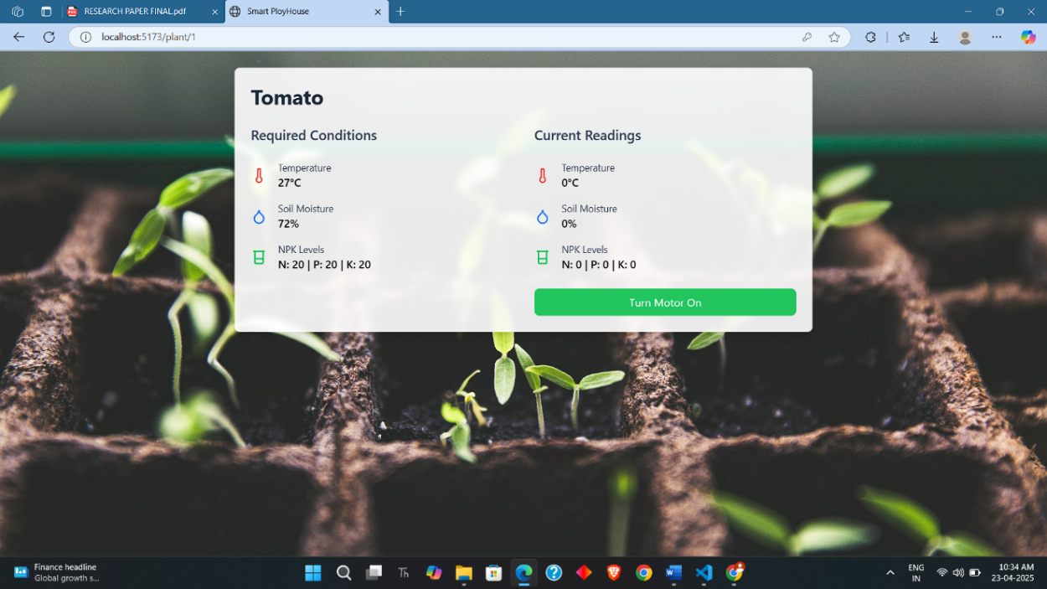

**Fig 6.2: Web Page Interface**

**6.5 Summary**

The chapter on Software Implementation of the Smart Polyhouse Irrigation Management System focuses on the design and functionality of the user interface and backend system. It describes how the system integrates various components, including sensor data collection, decision-making, and user interaction. The frontend includes a visually engaging homepage with animated plant graphics, a secure login page, and a dashboard displaying real-time sensor data (e.g., soil moisture, temperature, humidity, and NPK values). Users can interact with the system through plant search functionality,

detailed plant pages, and motor control buttons to manage irrigation based on sensor readings. The backend processes data received from sensors, performs logical evaluations, and communicates with the frontend for real-time updates. The system is designed to provide a seamless and interactive experience for monitoring and controlling the polyhouse environment, ensuring optimal conditions for plant growth.

**CHAPTER 7**

**RESULTS AND DISCUSSION**

**7.1 Introduction**

The Experimental Results chapter presents the testing and performance evaluation of the Smart Polyhouse Irrigation Management System, focusing on the system's accuracy in monitoring sensor data (soil moisture, temperature, humidity, and nutrients) and its effectiveness in automating irrigation and maintaining optimal plant conditions.

**Step 1: Code Upload and Configuration**

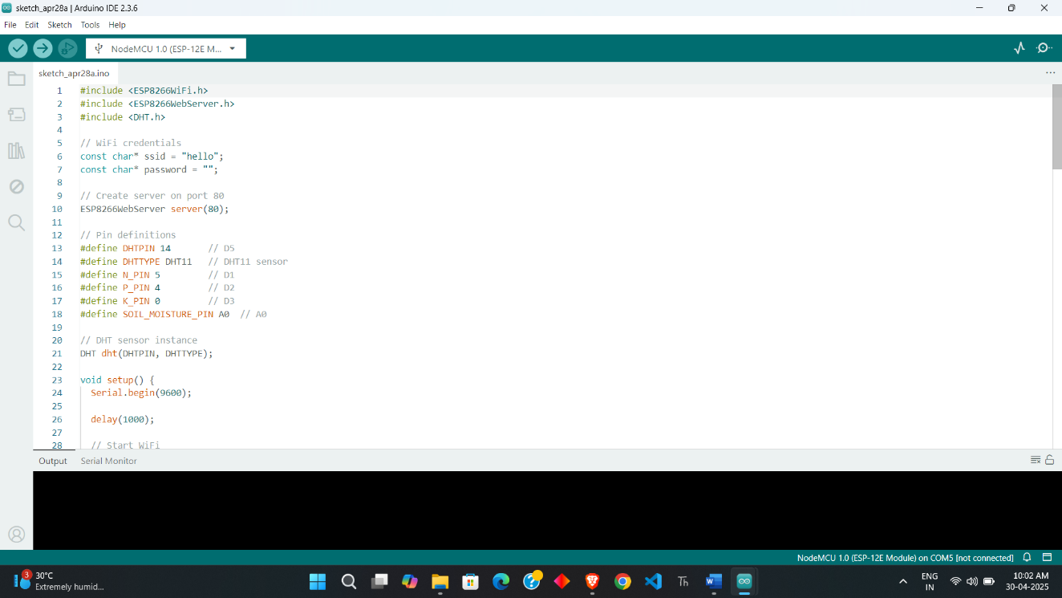Dumping code onto the ESP8266 is done via the Arduino IDE installed on a Windows OS. The dumping of code is shown in Figure 7.1.

**Fig 7.1: Dumping code to ESP8266**

To write and upload the code to the ESP8266 microcontroller, the Arduino IDE is used. The firmware is developed within the Arduino environment, incorporating the necessary libraries for HTTP communication, and sensor integration. After selecting the

correct board model (e.g., "NodeMCU 1.0 (ESP-12E Module)") and the appropriate COM port, the code is compiled and uploaded to the ESP8266. The upload process is monitored through the Arduino IDE, which provides real-time feedback in the console and displays a "Done uploading" message upon successful completion. Once uploaded, the ESP8266 connects to the configured WiFi network and begins interfacing with the sensors, making the system ready for testing and further functionality checks.

**Step 2: Sensor Data Reading**

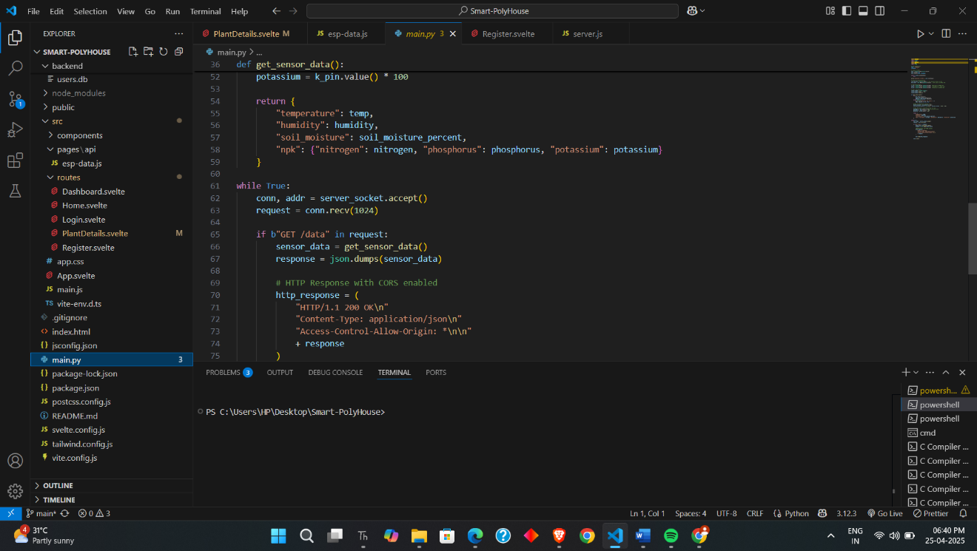

**Fig 7.2: Data is read from ESP8266**

The read data from the connected sensors, including soil moisture, temperature, humidity, and NPK sensors. The ESP8266 reads the sensor data from each device using their respective GPIO pins. The raw data is processed and formatted appropriately before being transmitted to the cloud using HTTP protocols, enabling real-time monitoring. As a result, the ESP8266 successfully retrieves sensor data shown in above Fig 7.2, including temperature, humidity, and soil moisture values, which are then displayed on the cloud-based dashboard. The data is updated in real-time, ensuring accurate and continuous monitoring of the system's conditions.

**Step 3: Dashboard Access**

The user to access the web-based dashboard to monitor environmental data. The process begins when the user launches the web interface through a browser or mobile app and logs in as in Fig 7.3. Upon successful authentication, the user is directed to the dashboard, where real-time data such as temperature, humidity, and soil moisture readings are displayed. As a result, the dashboard effectively shows updated sensor readings and status indicators, ensuring that the system is responsive. The real-time data is accurately reflected, providing users with a comprehensive overview of the polyhouse conditions for informed decision-making.



**Fig 7.3: Login Page**

**Step 4: Dashboard Overview**

The dashboard shows key environmental parameters and system status. The process involves the dashboard shown in below Fig 7.4 displaying live data on critical factors such as soil moisture, temperature, humidity, and NPK levels. Visual elements like charts, gauges, and status indicators are incorporated to present the data in a clear and intuitive manner. As a result, the dashboard provides an effective and user-friendly overview of the polyhouse environment, offering real-time updates on the condition of the plants and their growing conditions. This enables users to monitor and adjust the

environment as needed for optimal plant growth.

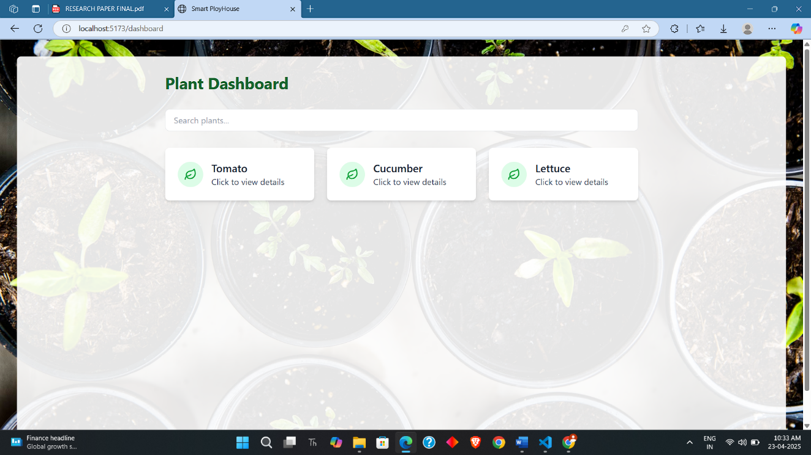

**Fig 7.4: Plant Dashboard**

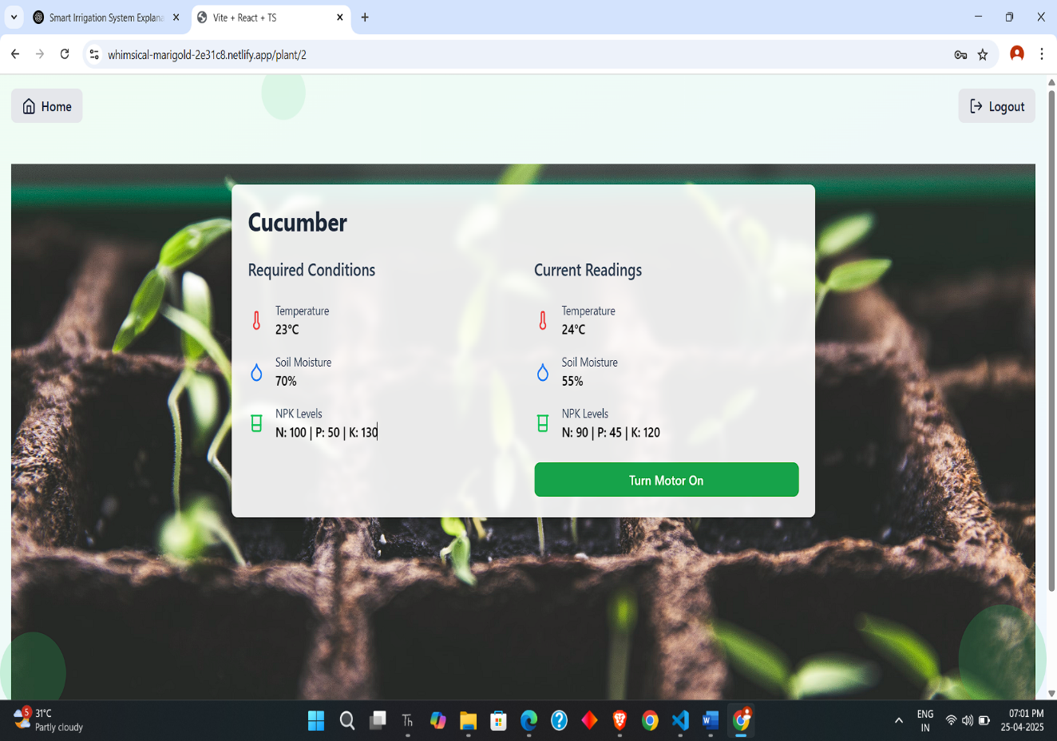**Step 5: Real-Time Monitoring and Irrigation Control**

**Fig 7.5: Real-Time Monitoring**

The system continuously monitors environmental conditions and sends alerts if any parameter deviates from the ideal range. The app or dashboard updates in real-time, displaying sensor readings such as temperature, humidity, and soil moisture. If any value exceeds or falls below predefined thresholds, the system triggers an alert to notify the user. For instance, if the soil moisture level is too low, an alert prompts the user to take corrective action. In addition, the system allows the user to control the irrigation motor based on these real-time sensor readings as shown in above Fig 7.5. Through the web interface, the user can remotely control the water pump. If the soil moisture level falls below the desired threshold, a "Turn ON" button appears, while a "Turn OFF" button is displayed when the moisture level is sufficient. This integration ensures that the user can effectively manage irrigation, optimizing water usage and maintaining the ideal growing conditions for the plants.

**CHAPTER 8**

**CONCLUSION**

**8.1 Conclusion**

In conclusion, our project effectively implements a smart polyhouse monitoring and irrigation system based on the ESP8266 microcontroller. The integration of multiple sensors such as soil moisture, DHT11 for temperature and humidity, and digital NPK sensors allows for comprehensive environmental monitoring. These sensors provide accurate, real-time data which is transmitted to a web-based dashboard, enabling users to remotely monitor and analyse critical conditions required for optimal plant growth.

Furthermore, the system includes an automated irrigation mechanism, controlled via motor commands from the dashboard. Depending on soil moisture levels, the system can trigger the water pump accordingly, reducing manual labour and ensuring efficient water usage. By combining automation with real-time monitoring and user-friendly controls, this project contributes to the advancement of precision agriculture and sustainable farming practices.

**8.2 Future Scope**

The smart polyhouse monitoring and irrigation system has great potential for future enhancement and scalability. One major improvement could be the integration of artificial intelligence (AI) and machine learning (ML) algorithms to predict environmental patterns and optimize irrigation schedules automatically. This would further reduce manual intervention and increase the accuracy of water and nutrient supply based on crop-specific requirements. Expanding the system to support wireless sensor networks (WSNs) and integrating solar-powered modules could enhance energy efficiency and make the solution more suitable for remote or off-grid agricultural areas. Cloud-based data analytics, mobile app enhancements, and multilingual support can also be incorporated to make the system more user-friendly and accessible to farmers across different regions.

## REFERENCES

## Manjunath Deshpande1, Shraddha Patil2, Priyanka Kanaka3, Diksha V M4 “Automatic Plant Irrigation Based on Soil Moisture and Monitoring Over IOT” International Journal of Innovative Research in Computer and Communication Engineering An ISO 3297: 2007 Certified Organization Vol.5, Special Issue 4, June 2017

## Pavankumar Naik, Arun Kumbi, Vishwanath Hiregoudar, Chaitra N K , Pavitra H K , Sushma B S, Sushmita J H , Praveen Kuntanahal “Arduino Based Automatic Irrigation System Using IoT ” International Journal of Scientific Research in Computer Science, Engineering and Information Technology © 2017 IJSRCSEIT | Volume 2 | Issue 3 | ISSN : 2456-3307

## Dr. N. K. Choudhari1, Mayuri Harde2 “Automated Plant Irrigation System Based on Soil Moisture and Monitoring Over IOT” Volume 5 Issue VI, June 2017 ICValue:45.98 ISSN: 2321-9653

## Nikhil Agrawal Engineeing Manager, Siemens, Noida , Smita Singhal ASET, Amity University, Noida “Smart Drip Irrigation System using Raspberry pi and Arduino” International Conference on Computing, Communication and Automation (ICCCA2015)

## Abhinav Rajpal, Sumit Jain, Nistha Khare and Anil Kumar Shukla “Microcontroller based Automatic Irrigation System with Moisture Sensors” Volume 5 Issue VI, June 2015

## Lorvanleuang, S. and Zhao, Y.D. “Automatic Irrigation System Using Android” Open Access Library Journal 2015, Volume 5, e4503 ISSN Online: 2333-9721 ISSN Print: 2333 9705

## Mayuri R. Harde, Dr. N. K. Choudhari “A Review Paper On Wireless Sensor Network And Gprs Module For Automated Irrigation”, International Research Journal of Engineering and Technology (IRJET), Volume: 04 Issue: 01 Jan -2017

## Souvanxay Lorvanleuang*, Yandong Zhao, ” Automatic Irrigation System Using Android 2018, Volume 5, e4503

## N Seenu, Manju Mohan, Jeevanath V S,“Android Based Intelligent Irrigation System”, International Journal of Pure and Applied Mathematics, Volume 119 No. 7 2018, 67-71

## Anand Dhore1, Arti Sanganwar2, Kapil Chalkhure3, Shivani Jijankar4, Prof. Vikramsingh R. Parihar5, ―Automatic Irrigation System Using Android Mobile , International Journal of Advanced Research in Computer and Communication Engineering ISO 3297:2007 Certified Vol. 6, Issue 9, September 2017

## Kachor, A. Y., & Ghodinde, K. (2019). Design of microcontroller based agribot for fertigation and plantation. 2019 International Conference on Intelligent Computing and Control Systems (ICCS). doi:10.1109/iccs45141.2019.9065768

## Hadi, M. S., Adi Nugraha, P., Wirawan, I. M., Ari Elbaith Zaeni, I., Mizar, M. A., & Irvan, M. (2020). IoT Based Smart Garden Irrigation System. 2020 4th International Conference on Vocational Education and Training (ICOVET). doi:10.1109/icovet50258.2020.923

## Rokade, Assistance and Control System for Polyhouse Plantation, M. Des. Thesis, IDC IIT Bombay, 2004. [9]. T. Ahonen, R. Virrankoski, M. Elmusrati, “Greenhouse Monitoring with Wireless Sensor Network”, IEEE /ASME International Conference on Mechatronic and Embedded Systems and Applications, 2008.

## Automation in Polyhouse using IOT prem kumar. S1, Karthik.S2,

## Karuppasamy.M3, Soundararajan.C4 1,2,3,4Final year, Electronics and Communication Engineering, Sengunthar Engineering College, (India)

## Polyhouse Technique using Raspberry Implemented in IOT. Mrs. Bharathi1, Dheena Jefrin Fathima2, Priyanka.D3, Swetha.S4. 1Assistant professor, S.A. Engineering College, Avadi, Chennai. 2,3,4 Electrical and Electronics department, S.A. Engineering college, Chennai, India.

## E.D. Lund1, V.I. Adamchuk2, K.L. Collings1, P.E. Drummond1 And C.D. Christy1 “” Development Of Soil Ph And Lime Requirement Maps Using On-The-Go Soil Sensors” University Of Nebraska-Lincoln, Lincoln, Lunde@Veristech.Com Ne 68583-0726, Usa

## Pranay Gopal Umate “Embedded System For Nutrient Managment In Controlled Agriculture” International Journal Of Research And Analysis Volume 3 Issue 2 ISSN 2347-3185, 2015.

## Gayatri Londhe and Prof. S.G. Galande “Automated Irrigation System By Using ARM Processor” International Journal of Scientific Research Engineering & Technology (IJSRET), ISSN 2278 – 0882 Volume 3 Issue 2, May 2014

## Anuj Kumar “Prototype Greenhouse Environment Monitoring System” international multi-Conference of engineers and computer science. 2010 hong kong.

## Hemlata Channe, Sukhesh Kothari, Dipali Kadam, “Multidisciplinary Model for Smart Agriculture using Internet-of-Things (IoT), Sensors, Cloud-Computing, Mobile-Computing & Big-Data Analysis”, International Journal of Int.J.Computer Technology &Applications,Vol 6 (3),May-June 2015.

## A. Thorat, S. Kumari and N. D. Valakunde, "An IoT based smart solution for leaf disease detection," 2017 International Conference on Big Data, IoT and Data Science

## (BID), Pune, 2017, pp. 193-198, doi: 10.1109/BID.2017.8336597.

## Nawaz, Muhammad & khan, Tehmina & Rasool, Rana & Kausar, Maryam & Usman, Amir & Naik Bukht, Tanvir Fatima & Ahmad, Rizwan & Ahmad, Jaleel. (2020). Plant Disease Detection using Internet of Thing (IoT). International Journal of Advanced Computer Science and Applications. 11. 10.14569/IJACSA.2020.0110162.

## Sladojevic S, Arsenovic M, Anderla A, Culibrk D, Stefanovic D. Deep Neural Networks Based Recognition of Plant Diseases by Leaf Image Classification. Comput Intell Neurosci. 2016;2016:3289801. doi: 10.1155/2016/3289801. Epub 2016 Jun 22. PMID: 27418923; PMCID: PMC4934169.

## Prema K, Carmel Mary Belinda, Smart Farming: IoT Based Plant Leaf Disease Detection and Prediction using Deep Neural Network with Image Processing, International Journal of Innovative Technology and Exploring Engineering (IJITEE)ISSN: 2278-3075, Volume-8 Issue-9, July, 2019

## Kim, S., Lee, M., & Shin, C. (2018). IoT-Based Strawberry Disease Prediction System for Switzerland), 18(11), 4051. Smart Farming. Sensors (Basel, Switzerland), 18(11), 4051.

## T. Ahonen, R. Virrankoski and M. Elmusrati, "Greenhouse Monitoring with Wireless Sensor Network," 2008 IEEE/ASME International Conference on Mechtronic and Embedded Systems and Applications, Beijing, China, 2008, pp. 403-408, doi: 10.1109/MESA.2008.4735744.

## Kareem, O.S., and Qaqos, N.N. (2019). Real-time implementation of greenhouse monitoring system based on wireless sensor network. International Journal of Recent Technology and Engineering 8, 215 219.

## L. Mainetti, L. Patrono and A. Vilei, "Evolution of wireless sensor networks

## towards the Internet of Things: A survey," SoftCOM 2011, 19th International Conference on Software, Telecommunications and Computer Networks, Split, Croatia, 2011, pp. 1-6.

## Deepashree, B., Chaithra, B.S., Niveditha, P.S., and Mr.Venkatesh, P. (2018). Smart Watering System using IoT. International Journal of Engineering Research & Technology 6, 1–3.

## Jayaty, BINANI, D., and NAGADEVI, M. (2018). IoT Based Polyhouse Monitoring and Control System. International Journal of Pure and Applied Mathematics 118, No.20, 4261–4265.

## Purnima, S.R.N. Reddy, “Design of Remote Monitoring and Control System with Automatic Irrigation System using GSM-Bluetooth” International Journal of Computer Applications (0975 – 888) Volume 47– No.12, June 2012

## Dr.D.Saraswathi, P.Manibharathy, R.Gokulnath, E.Sureshkumar, K.Karthikeyan. Automation of Hydroponics Green House Farmingusing IOT, 2018 IEEE International Conference on System, Computation, Automation and Networking (ICSCA), July 2018.

## Min Pack, Khanjan Mehta. Design of Affordable Greenhouses for East Africa, 2012 IEEE Global Humanitarian Technology Conference, pp. 105-110, 2012.

## Jonnala, Prathiba, and G. S. R. Sathyanarayana. "A Wireless Sensor Network For Polyhouse Cultivation Using Zigbee Technology." Arpn Journal Of Engineering And Applied Sciences Vol 10 (1819).

## Pawar, A. M., R. Patil, P Deshmukh S. Pathak, B. Gunjal "Wireless Sensor Network to Monitor Spatio Temporal Thermal Comfort of Polyhouse Environment." International Journal of Innovative Research in Science, Engineering and Technology 2.10 (2013): 4866-4875.

## J. Gutierrez, J. F. Villa-Medina, A. Nieto-Garibay, and M. ´ A. Porta G´andara, “Automated irrigation system using a wireless sensor network and gprs module,” IEEE transactions on instrumentation and measure ment, vol. 63, no. 1, pp. 166–176, 2013.

## R. Khan, I. Ali, M. Zakarya, M. Ahmad, M. Imran, and M. Shoaib, “Technology-assisted decision support system for efficient water utiliza tion: a real-time testbed for irrigation using wireless sensor networks,” IEEE Access, vol. 6, pp. 25686–25697, 2018.

## L. J. Klein, H. F. Hamann, N. Hinds, S. Guha, L. Sanchez, B. Sams, and N. Dokoozlian, “Closed loop controlled precision irrigation sensor network,” IEEE Internet of Things Journal, vol. 5, no. 6, pp. 4580–4588, 2018.

## S. Agarwal and N. Agarwal, “An algorithm based low cost automated system for irrigation with soil moisture sensor,” in 2017 International Conference on Computer Communication and Informatics (ICCCI), pp. 1–5, IEEE, 2017.

## V. Pastushenko and A. Stetsenko, “Development, modeling and technical implementation of automated control system of soil’s moistness by underground irrigation,” in 2010 International Conference on Modern Problems of Radio Engineering, Telecommunications and Computer Science (TCSET), pp. 33–33, IEEE, 2010.

## D. R. Khade, N. V. Gajane, S. N. Gawade, and R. A. Metri, “Intensity controller of led street lights,” in 2017 International Conference on Circuit ,Power and Computing Technologies (ICCPCT), pp. 1–4, 2017.

## O. R. Kulkarni and R. Metri, “Automatic toll monitoring system using plc-scada programming,” in 2019 9th International Conference on Cloud Computing, Data Science & Engineering (Confluence), pp. 126–129, IEEE, 2019.

## R. A. Metri and B. A. Rajpathak, “Computation of control law for state transfer

## problem in efficient way for a single input,” IEEE Transactions on Industry Applications, vol. 58, no. 3, pp. 4098–4108, 2022.

## B. D. Kumar, P. Srivastava, R. Agrawal, and V. Tiwari, “Microcontroller based automatic plant irrigation system,” International Research Journal of Engineering and Technology, vol. 4, no. 5, pp. 1436–1439, 2017.

## G. Banerjee and R. Singhal, “Microcontroller based polyhouse automa tion controller,” in 2010 International Symposium on Electronic System Design, pp. 158–162, IEEE, 2010.

## Dr. S. Jaisankar,Dr. P. Nalini, K. Krishna Rubigha, “A Study on IoT based Low-Cost Smart Kit for Coconut Farm Management”, Proceedings of the Fourth International Conference on I-SMAC (IoT in Social, Mobile, Analytics and Cloud) (I-SMAC) IEEE Xplore Part Number: CFP20OSV-ART; ISBN: 978-1-7281-5464-0.

## Narendra Kumar,Anil Kumar Dahiya, Sarvesh Tanwar, Krishna Kumar, “Application of IoT in Agriculture”, 2021 9th International Conference on Reliability, Infocom Technologies and Optimization (Trends and Future Directions) (ICRITO) Amity University, Noida, India. Sep 3-4, 2021.

## Adesh Kumar Pandey1, Minakshi Chauhan2, “IOT Based Smart Polyhouse System using Data Analysis”, 2019 2nd International Conference on Issues and Challenges in Intelligent Computing Techniques (ICICT).

## Jonnala, Prathiba, and Sadulla Shaik. "Wireless solution for polyhouse cultivation using embedded system." 2013 International Conference on Renewable Energy and Sustainable Energy (ICRESE). IEEE, 2013.

## Dagar, Rahul, Subhranil Som, and Sunil Khatri. "Smart farming IoT in agriculture." International Conference on Inventive Research in Computing IEEE, 2018.